*A project report on*

**ANALYSIS OF MACHINE LEARNING MODELS IN HEART DISEASE PREDICTION**

*Submitted in partial fulfilment for the award of the degree of*

**MTech (Integrated) - Software Engineering**

*by*

**K.RASHMI (16MIS0299)**



**SCHOOL OF INFORMATION TECHNOLOGY AND ENGINEERING**

June,2021

**ANALYSIS OF MACHINE LEARNING MODELS IN HEART DISEASE PREDICTION**

*Submitted in partial fulfilment for the award of the degree of*

**MTech (Integrated) - Software Engineering**

*by*

**K.RASHMI (16MIS0299)**



**SCHOOL OF INFORMATION TECHNOLOGY AND ENGINEERING**

June,2021

**DECLARATION**

I hereby declare that the thesis entitled “ANALYSIS OF MACHINE LEARNING MODELS IN HEART DISEASE PREDICTION” submitted by me, for the award of the degree of Masters of Technology in Software Engineering VIT is a record of bonafide work carried out by me under the supervision of DR. SUBA SHANTHINI S.

I further declare that the work reported in this thesis has not been submitted and will not be submitted, either in part or in full, for the award of any other degree or diploma in this institute or any other institute or university.

Place: Vellore 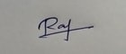

Date: Signature of the Candidate

**CERTIFICATE**

This is to certify that the thesis entitled “ANALYSIS OF MACHINE LEARNING MODELS IN HEART DISEASE PREDICTION**”** submitted by K.RASHMI (16MIS0299) SITE VIT, for the award of the degree of MTech Integrated - Software Engineering is a record of bonafide work carried out by him/her under my supervision

The contents of this report have not been submitted and will not be submitted  
either in part or in full, for the award of any other degree or diploma in this institute or  
any other institute or university. The Project report fulfils the requirements and regulations of  
VIT and in my opinion meets the necessary standards for submission.

**Signature of the Guide**  **Signature of the HoD**

**Internal Examiner**  **External Examiner**

**ABSTRACT**

Now a day’s heart disease is the leading cause of death. From newborn children to old age people with heart disease have become common. Some are being affected due to high blood pressure, high cholesterol level, smoking, inheritance from their family, and many other factors affecting the heart, and predicting heart disease with accurate results is not an easy task. For the time being there are many algorithms focused on how to improve the accuracy rate, but the results shown were not good. The algorithms used are combined with other algorithms to improve the accuracy rate but the results shown are not enough. The use of DNN improved the rate and also other algorithms like random forest, specificity, sensitivity. In this project, I will compare the accuracy results of different algorithms and show the best accuracy among all.

**ACKNOWLEDGEMENT**

It is my pleasure to express with deep sense of gratitude to Dr. SUBA SHANTHINI S, Assistant Professor (Sr) Grade 1, Information Technology, SITE, Vellore Institute of Technology, for her constant guidance, continual encouragement, understanding; more than all, he taught me patience in my endeavour. My association with her is not confined to academics only, but it is a great opportunity on my part of work with an intellectual and expert in the field of Information security.

I would like to express my gratitude to Chancellor Dr. G. Viswanathan, Vice president Mr.G.V.Selvam, Vice-Chancellor Dr. Rambabu Kondali, Pro-Vice-Chancellor Dr. S. Narayanan, and Dr.Balakrushna Tripathy, Dean, School of Information Technology and Engineering for providing with an environment to work in and for his inspiration during the tenure of the course.

In jubilant mood I express ingeniously my whole-hearted thanks to Dr. Shantharajah S P, Head of the Department, Software and System Engineering all teaching staff and members working as limbs of our university for their not-self-centered enthusiasm coupled with timely encouragements showered on me with zeal, which prompted the acquirement of the requisite knowledge to finalize my course study successfully. I would like to thank my parents for their support.

It is indeed a pleasure to thank my friends who persuaded and encouraged me to take up and complete this task. At last but not least, I express my gratitude and appreciation to all those who have helped me directly or indirectly toward the successful completion of this project.

Place: Vellore K.Rashmi

Date: Name of the student

**CONTENTS**

|  |  |  |  |
| --- | --- | --- | --- |
| **CHAPTER NO** |  | **TITLE** | **PAGE NO** |
|  |  | Abstract | i |
|  |  | Acknowledgment | ii |
|  |  | Contents | iii |
|  |  | List of figures | v |
|  |  | List of Abbreviations | vii |
|  |  |  |  |
| 1. |  | Introduction |  |
|  | 1.1 | Introduction | 1 |
|  | 1.2 | Problem statement | 1 |
|  | 1.3 | Objective | 1 |
|  | 1.4 | Scope of the project | 2 |
|  |  |  |  |
|  |  |  |  |
| 2. |  | Background |  |
|  | 2.1 | Literature survey | 3 |
|  | 2.2 | Methodology | 6 |
|  |  |  |  |
|  |  |  |  |
| 3. |  | System Specifications |  |
|  | 3.1 | Hardware Requirements | 8 |
|  | 3.2 | Software Requirements | 8 |
|  | 3.3 | Module | 9 |
|  | 3.4 | Module Description | 9 |
|  | 3.5 | System Architecture | 10 |
|  |  |  |  |
| 4 |  | Detailed design |  |
|  | 4.1 | Usecase Diagram | 11 |
|  | 4.2 | Class Diagram | 12 |
|  | 4.3 | State Diagram | 13 |
|  |  |  |  |
| 5. |  | Implementation |  |
|  | 5.1 | Code | 14 |
|  | 5.2 | Screen Shots | 50 |
|  |  |  |  |
| 6. |  | Conclusion |  |
|  | 6.1 | Conclusion | 60 |
|  | 6.2 | Future Scope | 60 |
|  |  |  |  |
| 7. |  | Reference |  |
|  | 7.1 | Reference | 61 |
|  | 7.2 | Base paper | 62 |

**LIST OF FIGURES**

|  |  |
| --- | --- |
| Figures | PAGE NO |
| Fig.3.5.1 System Architecture | 10 |
| Fig4.1.1 Usecase diagram | 11 |
| Fig4.2.1 class diagram | 12 |
| Fig4.3.1 State diagram | 13 |
| Fig.5.2.1 Adaboost algorithm Accuracy before pre-processing | 50 |
| Fig.5.2.2 Adaboost algorithm Accuracy after pre-processing | 50 |
| Fig.5.2.3 Decision Tree Accuracy before pre-processing | 50 |
| Fig.5.2.4 Decision Tree Accuracy after pre-processing | 50 |
| Fig.5.2.5 KNN Accuracy before pre-processing | 51 |
| Fig.5.2.6 KNN Accuracy after pre-processing | 51 |
| Fig.5.2.7 Logistic Regression Accuracy before pre-processing | 51 |
| Fig.5.2.8 Logistic Regression Accuracy after pre-processing | 51 |
| Fig.5.2.9 Random Forest algorithm accuracy before pre-processing | 52 |
| Fig.5.2.10 Random Forest algorithm accuracy after pre-processing | 52 |
| Fig.5.2.11 SVM algorithm accuracy before pre-processing | 52 |
| Fig.5.2.12 SVM algorithm accuracy after pre-processing | 52 |
| Fig.5.2.13 XGBoost algorithm accuracy before pre-processing | 53 |
| Fig.5.2.14 XGBoost algorithm accuracy after pre-processing | 53 |
| Fig.5.2.15 Graph representing all algorithms accuracy for Confusion Matrix | 53 |
| Fig.5.2.16 Graph representing all algorithms accuracy for Recall of Confusion Matrix | 54 |
| Fig.5.2.17 Graph representing all algorithms accuracy for Precision of Confusion Matrix | 54 |
| Fig.5.2.18 Graph representing all algorithms accuracy for Grid Search | 55 |
| Fig.5.2.19 Main page | 55 |
| Fig.5.2.20 Prevent page - 1 | 56 |
| Fig.5.2.21 Prevent page – 2 | 56 |
| Fig.5.2.22 Symptom’s page | 57 |
| Fig.5.2.23 Test page -1 | 57 |
| Fig.5.2.24 Test page - 2 | 58 |
| Fig.5.2.25 Analysis page – 1 | 58 |
| Fig.5.2.26 Analysis page - 2 | 59 |
| Fig.5.2.27 Analysis page – 3 | 59 |

**LIST OF ABBREVIATION**

|  |  |
| --- | --- |
| DNN | Deep Neural Network |
| NB | Naive Bayes |
| BP | Blood Pressure |
| IoT | Internet of Things |
| PCA | Principle Component Analysis |
| KNN | K-Nearest Neighbors |
| SVM | Support Vector Machine |
| ANN | Artificial Neural Network |

**Chapter 1**

**Introduction**

* 1. INTRODUCTION

Currently, heart disease has become very common as BP, Sugar. Irrespective of the age, gender the disease has been attacking. Right from newborn to old age people are getting various types of heart disease like Dilated Cardiomyopathy, Heart Failure. The most common symptoms the patients face are shortness of breath, cannot be able to walk for some distance, cannot be able to sleep. Based on these factors the doctors recommend the test and diagnosis of disease, accordingly, they recommend tablets and if needed they will perform surgery.

* 1. PROBLEM STATEMENT

The project main idea is to know whether the patient is suffering from heart disease or not based on the data given and applied on various Machine Learning algorithms to find which algorithm has given the best accuracy to predict disease.

* 1. OBJECTIVE

Machine Learning has taken the technology by providing the best results which are not predicted before and within less time. The same Machine Learning algorithms when applied in medical diagnosis they help the doctors to predict the disease and treat it accordingly. The number of deaths due to heart disease has been increasing day by day. The number is increasing daily to avoid the death rate taking the help of machine learning concepts applying it into the data can help the doctors to predict properly and save the patient.

* 1. SCOPE OF THE PROJECT

The main aim of this project is to know which algorithm of Machine Learning concepts is giving the highest accuracy after training with the data. The algorithm which gives us the best results can be applied and predict accurately which saves the patient’s life.

**Chapter 2**

**Background**

* 1. LITERATURE SURVEY

|  |  |  |  |  |
| --- | --- | --- | --- | --- |
| **S.No** | **Title** | **Author** | **Technique used** | **Description** |
| **1** | An Effective Heart Disease Prediction Model for a Clinical Decision Support System  Year: 2020 | Norma Latif Fitriyani, Muhammad syafrudin, Ganjar Alfian and Jongtae Rhee | Density-Based Spatial Clustering of Applications with Noise (DBSCAN) | In this paper, the dataset is pre-processed and outliers detected, later data is balanced by XGBoost, and performance is done. The accuracy achieved is 98.50% which gives the best model when compared with other algorithms. |
| **2** | An IoT Framework for Heart Disease Prediction Based on MDCNN Classifier  Year: 2020 | Mohammad Ayoub khan | Modified Deep Convolutional Neural Network (MDCNN) | With the MDCNN the accuracy achieved is around 98.2%, this paper is mainly focused on a wearable device to monitor the heart rate. |
| **3** | Coronary Artery Heart Disease Prediction: A Comparative Study of Computational Intelligence Techniques  Year: 2020 | Safial Islam Ayon, Md. Milon Islam & Md. Rahat Hossain | Logistic Regression (LR), Support Vector Machine (SVM), Deep Neural Network (DNN), Decision Tree (DT), Naïve Bayes (NB), Random Forest (RF), and K-Nearest Neighbor (K-NN | Highest accuracy obtained from Deep Neural Network of 98.15% from the seven algorithms. Thus, this accuracy will help the medical team to predict accurately. |
| **4** | Classification models for heart disease prediction using feature selection and PCA Year: 2020 | Anna Karen Garate-Escamila, Amir Hajjam EI Hassani, Emmanuel Andres | Feature selection and PCA | In this paper, the dataset taken contains 74 features. The accuracy gained by Chi-square and principal component analysis with random forest is 98.7% and different accuracy as the dataset changed but all are above 98%. To improve the data results they used the dimensionality reduction technique. |
| **5** | An efficient convolutional neural network for coronary heart disease prediction Year:2020 | Aniruddha Dutta, Tamal Batabyal, Meheli Basu, Scott T.Acton | Convolutional neural network (CNN) | The accuracy achieved by the test of dataset is 77% but after test data they achieved 85.70% of accuracy. The reason for choosing the CNN is which results high specificity and test accuracy. |
| **6** | Improved sparse autoencoder based artificial neural network approach for prediction of heart disease Year:2020 | Ibomoiye Domor Mienye, Yanxia Sun, Zenghui Wang | sparse autoencoder (SAE), artificial neural network (ANN) | By using the neural networks, they gained the accuracy of 92.8% for sensitivity, 88.6% for specificity. They performed feature reduction which impact the performance. |
| **7** | Classification of Heart Disease using Decision Tree Algorithm  Year:2020 | AIshak, AGinting, KSiregar, CJunika | Decision tree | Used Orange Data Mining Software, where the data is imported and result was decision tree with detailed tree structure. When compare d with other Machine Learning algorithms this ANN showed better results. |
| **8** | Heart Disease Prediction Using Machine Learning Algorithms  Year:2020 | Archana Singh, Rakesh Kuma | k-nearest neighbor, decision tree, linear regression and support vector machine (SVM) | This paper performs four different algorithms to check the most accurate one, but the result depends on the dataset, training and testing the data. After performing the highest accuracy given by k-nearest neighbor. |
| **9** | An effective disease prediction system using incremental feature selection and temporal convolutional neural network  Year:2020 | S. Sandhiya, U. Palani | Linear Correlation Coefficient based Feature Selection (ICRF-LCFS) | The proposed algorithm can achieve better accuracy in no time. The ICRF-LCFS not only predicts heart disease but also predict diabetic and cancer disease. The accuracy achieved from 93%. |
| **10** | A Hybrid Intelligent System Framework for the Prediction of Heart Disease Using Machine Learning Algorithms Year:2018 | Amin Ul Haq, Jian Ping Li, Muhammad Hammad Memo, Shah Nazi, Ruinan Sun | Logistic-regression, K-NN, ANN, SVM, NB, DT, and random forest | In this paper the accuracy achieved bu logigistic regression with 10-fold cross-validation showed the best accuracy of 89% and with feature selection the mRAM performance was the best. |

* 1. METHODOLOGY
     1. ADABOOST ALGORITHM

Adaboost knows as Adaptive Boosting is defined as the boosting technique which boosts the performance of the algorithm.

The algorithm combines multiple classifiers to increase the accuracy of the classifier.

* + 1. DECISION TREE ALGORITHM

Decision tree comes under supervised learning, which can solve regression and classification problem.

The main goal of this algorithm is to create a training model that can be used to predict the class or variable of the target variable. This is used to solve classification (predicting a label) and regression (predicting a quantity) problems in the form of trees.

* + 1. KNN (K-NEAREST ALGORITHM)

KNN which is K-Nearest Neighbours uses the data given for training, from the data given it separates, and similar points are taken which classifies a new data point based on the similarities.

The KNN falls under supervised learning algorithm that can be used for classification and regression problems.

* + 1. LOGISTIC REGRESSION

Logistic Regression can be defined as the statistical model that uses logistic function to model the conditional probability where nature of target can be 1 or 0. It is a supervised learning algorithm

* + 1. RANDOM FOREST ALGORITHM

Random forest builds the multiple decision trees from the data provided and then merges them together to get best accurate result.

It belongs to the family of supervised learning. It is used for classification and regression, but mainly used for classification problems. It is most flexible and easy to use.

* + 1. SVM (SUPPORT VECTOR MACHINE)

Support Vector Machine finds the closet point of the lines from both the classes.

It is a supervised learning algorithm which can be used for regression and classification challenges. The goal of SVM is to identify an optimal separation hyperplane.

* + 1. XGBOOST ALGORITHM

XGBoost is a decision tree-based ensemble machine learning algorithm that uses a gradient boosting framework.

It is a scalable and accurate implementation of gradient boosting machine and it is developed for the purpose of model performance and computational speed.

* + 1. GRID SEARCH

Grid search builds a model for every combination of hyperparameters specified and evaluates each model.

It is applied across machine learning to calculate the best parameters to use for any given model.

* + 1. CONFUSION MATRIX

Confusion matric is a table used to predict the performance of a classification model based on set of test data for which the true values are known.

In machine learning it summarizes the performance of a classification algorithm.

**Chapter 3**

**System Specification**

3.1 HARDWARE REQUIREMENT

Hardware Requirement is known as the common requirements which are needed for the operating system to work.

* PROCESSOR : Intel® Core ™ i5-5200U CPU @ 2.20GHz 2.19GHz
* RAM : 8.00 GB
* MONITOR : 14” COLOR
* HARD DISK : 512 SSD

3.2 SOFTWARE REQUIREMENT

The software requirements are needed for the project to work which gives us the best result. This requirement helps to find the solutions based on the code which we input and output is the required one.

* OPEN SOURCE SOFTWARE : Anaconda 3
* IDE : Jupyter
* FRONT END : Visual studio
* OPERATING SYSTEM : Windows 10

3.3 MODULES:

1. Dataset
2. Pre-processing
3. Splitting the data
4. Apply of algorithms
5. Result comparison

3.4 MODULES DESCRIPTION

3.4.1 DATASET

First step in this project is to have the dataset for the heart disease prediction which is taken from the Kaggle website. This dataset is used for the prediction and also able to know the accuracy rate for the applied algorithm.

3.4.2 PRE-PROCESSING

The second module describes the pre-processing of the data for the taken dataset. The dataset taken has any null value or no value, does it have any noisy data, and also standardization is applied to keep the mean and standard deviation values at 0 and 1 for best performance. All of these identified and the appropriate steps are taken to overcome these data.

3.4.3 SPLITTING THE DATA

The third module describes the splitting of data. For any algorithm to know whether it has performed well or not it is tested. For that purpose, the dataset is divided into train data and test data. Before that the data is separated into features and target value.

3.4.4 ALGORITHMS

The train data is taken and tested with the algorithms Decision Tree algorithm, Random Forest, Logistic Regression, SVM algorithm, KNN, Adaboost, XGBoost algorithms. The algorithm gives the appropriate results. To check the result percentage use accuracy rate and calculate it.

3.4.5 RESULT

This module describes the accuracy rate calculated. The accuracy of the different algorithms is compared and the best is chosen.

3.5 SYSTEM ARCHITECTURE

Algorithm Applied

Train and Test data

Dataset

Preprocessing

Result/Accuracy

Fig.3.5.1 System Architecture

**Chapter 4**

**Detailed diagrams**

4.1 USECASE DIAGRAM

The main purpose of a use case diagram is to show what system functions are performed for which actor. Roles of the actors in the system can be depicted. The below diagram shows how it is performed.

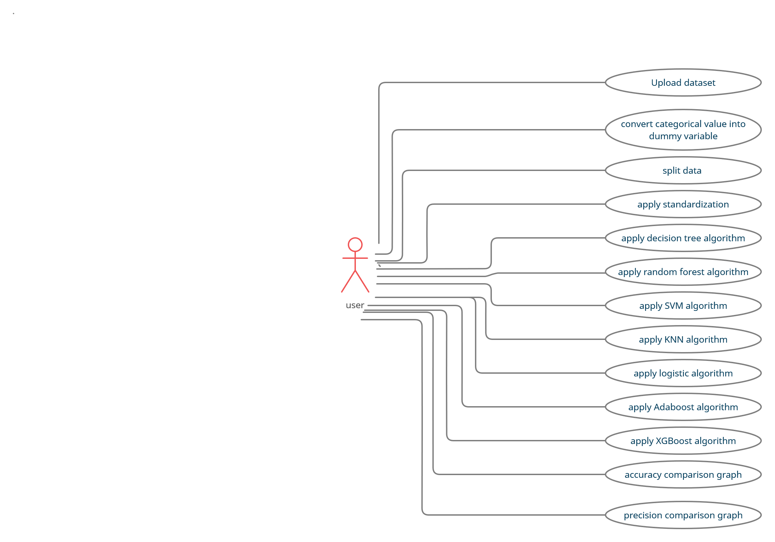

Fig4.1.1 Usecase diagram

4.2 CLASS DIAGRAM

In this class diagram represents how the classes with attributes and methods are linked together to perform the verification with security. The below diagram shown the various classes involved in our project.

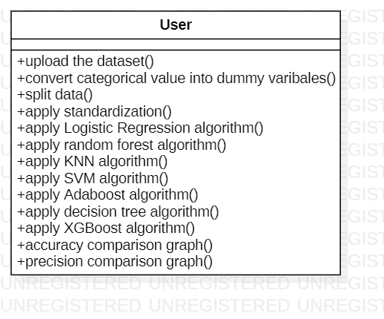

Fig4.2.1 class diagram

4.3 STATE DIAGRAM

State diagram are a loosely defined diagram to show workflows of stepwise activities and actions, with support for choice, iteration and concurrency. State diagrams require that the system described is composed of a finite number of states; sometimes, this is indeed the case, while at other times this is a reasonable abstraction. Many forms of state diagrams exist, which differ slightly and have different semantic.

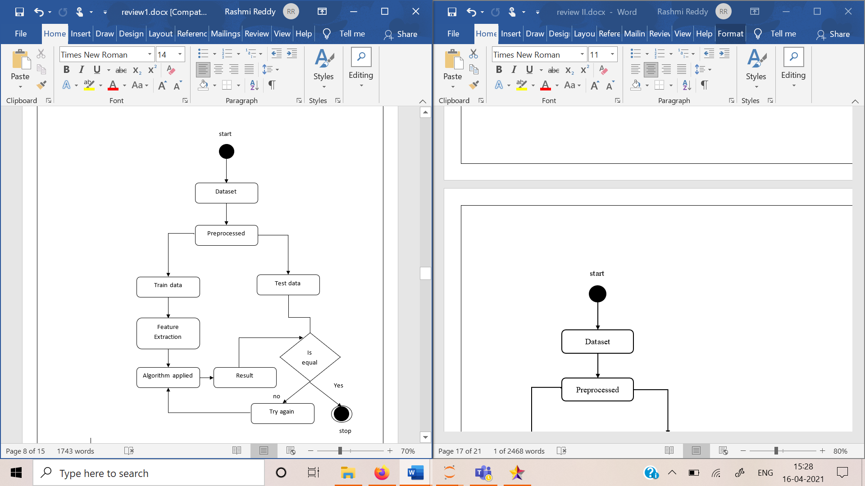

Fig4.3.1 State diagram

**Chapter 5**

**Implementation**

* 1. CODE
     1. ADABOOST ALGORITHM

import pandas as pd

import numpy as nm

data=pd.read_csv(r'D:\SEM 5_2\project\heart.csv')

data.head()

corr = data.corr()

corr.style.background_gradient(cmap='coolwarm')

cp = pd.get_dummies(data['cp'], prefix = "cp", drop_first=True)

thal = pd.get_dummies(data['thal'], prefix = "thal" , drop_first=True)

slope = pd.get_dummies(data['slope'], prefix = "slope", drop_first=True)

new_data = pd.concat([data, cp, thal, slope], axis=1)

new_data.drop(['cp', 'thal', 'slope'], axis=1, inplace=True)

new_data

X = new_data.iloc[:,:-1].values

y = new_data.iloc[:,-1].values

print('shape of X: ',X.shape)

from sklearn.model_selection import train_test_split

X_train,X_test,y_train,y_test=train_test_split(X,y,test_size=0.25,random_state=0)

from sklearn.preprocessing import StandardScaler

Sc = StandardScaler()

X_train = Sc.fit_transform(X_train)

X_test = Sc.transform(X_test)

from sklearn.ensemble import AdaBoostClassifier

from sklearn.tree import DecisionTreeClassifier

classifier = AdaBoostClassifier(

DecisionTreeClassifier(max_depth=1),

n_estimators=200)

classifier.fit(X_train, y_train)

y_pred=classifier.predict(X_test)

from sklearn import metrics

cnf_matrix = metrics.confusion_matrix(y_test, y_pred)

cnf_matrix

print("Accuracy:",metrics.accuracy_score(y_test, y_pred))

print("Precision:",metrics.precision_score(y_test, y_pred))

print("Recall:",metrics.recall_score(y_test, y_pred))

from sklearn.model_selection import GridSearchCV

param_grid = {

'n_estimators': [100, 200, 300,400],

'learning_rate': [0.005, 0.01, 0.03, 0.05, 0.1]}

AB = AdaBoostClassifier(random_state=0)

grid_search = GridSearchCV(estimator = AB, param_grid = param_grid,

cv = 10, n_jobs = -1, verbose=2)

grid_search = grid_search.fit(X_train, y_train)

print("best accuracy is :" , grid_search.best_score_)

grid_search.best_params_

AB = AdaBoostClassifier(n_estimators=200 ,

learning_rate=0.005, random_state=0)

AB.fit(X_train, y_train)

print('train accuracy', AB.score(X_train, y_train))

print('test accuracy ', AB.score(X_test, AB.predict(X_test)))

#After converting the categorical values

print("Before Grid Search Accuracy: ",metrics.accuracy_score(y_test, y_pred))

print("After Grid Search Accuracy: ",grid_search.best_score_)

#Before converting the categorical values

print("Before Grid Search Accuracy: ",metrics.accuracy_score(y_test, y_pred))

print("After Grid Search Accuracy: ",grid_search.best_score_)

* + 1. DECISION TREE ALGORITHM

import pandas as pd

import numpy as nm

data=pd.read_csv(r'D:\SEM 5_2\project\heart.csv')

data.head()

corr = data.corr()

corr.style.background_gradient(cmap='coolwarm')

cp = pd.get_dummies(data['cp'], prefix = "cp", drop_first=True)

thal = pd.get_dummies(data['thal'], prefix = "thal" , drop_first=True)

slope = pd.get_dummies(data['slope'], prefix = "slope", drop_first=True)

new_data = pd.concat([data, cp, thal, slope], axis=1)

new_data.drop(['cp', 'thal', 'slope'], axis=1, inplace=True)

new_data

X = new_data.iloc[:,:-1].values

y = new_data.iloc[:,-1].values

from sklearn.model_selection import train_test_split

X_train,X_test,y_train,y_test=train_test_split(X,y,test_size=0.25,random_state=0)

from sklearn.preprocessing import StandardScaler

Sc = StandardScaler()

X_train = Sc.fit_transform(X_train)

X_test = Sc.transform(X_test)

from sklearn.tree import DecisionTreeClassifier

dt=DecisionTreeClassifier(max_depth=3)

dt.fit(X_train,y_train)

y_pred=dt.predict(X_test)

from sklearn import metrics

cnf_matrix = metrics.confusion_matrix(y_test, y_pred)

cnf_matrix

print("Accuracy:",metrics.accuracy_score(y_test, y_pred))

print("Precision:",metrics.precision_score(y_test, y_pred))

print("Recall:",metrics.recall_score(y_test, y_pred))

from sklearn.model_selection import GridSearchCV

import numpy as np

DT = DecisionTreeClassifier(random_state=0) # Instantiate Decision Tree model

parameters = [{'max_depth': np.arange(16), 'min_samples_leaf': np.arange(16),

'criterion' : ['gini', 'entropy']}]

grid_search = GridSearchCV(estimator = DT, param_grid = parameters, cv = 10, n_jobs = -1)

grid_search = grid_search.fit(X_train, y_train)

print("best accuracy is :" , grid_search.best_score_)

grid_search.best_params_

DT = DecisionTreeClassifier(max_depth=2, min_samples_leaf=1,

criterion='gini', random_state=0)

DT.fit(X_train, y_train)

print('train accuracy', DT.score(X_train, y_train))

print('test accuracy', DT.score(X_test, DT.predict(X_test)))

#After converting the categorical values

print("Before Grid Search Accuracy: ",metrics.accuracy_score(y_test, y_pred))

print("After Grid Search Best accuracy is :" , grid_search.best_score_)

#Before converting the categorical values

print("Before Grid Search Accuracy: ",metrics.accuracy_score(y_test, y_pred))

print("After Grid Search Best accuracy is :" , grid_search.best_score_)

* + 1. KNN

import pandas as pd

data=pd.read_csv(r'D:\SEM 5_2\project\heart.csv')

data.head()

corr = data.corr()

corr.style.background_gradient(cmap='coolwarm')

cp = pd.get_dummies(data['cp'], prefix = "cp", drop_first=True)

thal = pd.get_dummies(data['thal'], prefix = "thal" , drop_first=True)

slope = pd.get_dummies(data['slope'], prefix = "slope", drop_first=True)

new_data = pd.concat([data, cp, thal, slope], axis=1)

new_data.drop(['cp', 'thal', 'slope'], axis=1, inplace=True)

new_data

X = new_data.iloc[:,:-1].values

y = new_data.iloc[:,-1].values

print('shape of X: ',X.shape)

from sklearn.model_selection import train_test_split

X_train,X_test,y_train,y_test=train_test_split(X,y,test_size=0.25,random_state=0)

from sklearn.preprocessing import StandardScaler

Sc = StandardScaler()

X_train = Sc.fit_transform(X_train)

X_test = Sc.transform(X_test)

from sklearn.neighbors import KNeighborsClassifier

from sklearn.metrics import accuracy_score

# Instantiate KNN learning model(k=10)

knn = KNeighborsClassifier(n_neighbors=10)

# fit the model

knn.fit(X_train, y_train)

y_pred=knn.predict(X_test)

from sklearn import metrics

cnf_matrix = metrics.confusion_matrix(y_test, y_pred)

cnf_matrix

print("Accuracy:",metrics.accuracy_score(y_test, y_pred))

print("Precision:",metrics.precision_score(y_test, y_pred))

print("Recall:",metrics.recall_score(y_test, y_pred))

import numpy as np

from sklearn.model_selection import GridSearchCV

KNC = KNeighborsClassifier()

parameters = [{'n_neighbors': np.arange(16)}]

grid_search = GridSearchCV(estimator = KNC, param_grid = parameters, cv = 5, n_jobs = -1)

grid_search = grid_search.fit(X_train, y_train)

print("best accuracy is :" , grid_search.best_score_)

grid_search.best_params_

KNC = KNeighborsClassifier(n_neighbors=8)

KNC.fit(X_train, y_train)

print('train accuracy', KNC.score(X_train, y_train))

print('test accuracy', KNC.score(X_test, KNC.predict(X_test)))

#after converting the categorical values

print("Before Grid Search Accuracy: ",metrics.accuracy_score(y_test, y_pred))

print("After Grid search Best Accuracy is :" , grid_search.best_score_)

#before coverting the categorical values

print("Before Grid Search Accuracy: ",metrics.accuracy_score(y_test, y_pred))

print("After Grid search Best Accuracy is :" , grid_search.best_score_)

* + 1. LOGISTIC REGRESSION

import pandas as pd

data=pd.read_csv(r'D:\SEM 5_2\project\heart.csv')

data.head()

corr = data.corr()

corr.style.background_gradient(cmap='coolwarm')

cp = pd.get_dummies(data['cp'], prefix = "cp", drop_first=True)

thal = pd.get_dummies(data['thal'], prefix = "thal" , drop_first=True)

slope = pd.get_dummies(data['slope'], prefix = "slope", drop_first=True)

new_data = pd.concat([data, cp, thal, slope], axis=1)

new_data.drop(['cp', 'thal', 'slope'], axis=1, inplace=True)

new_data

X = new_data.iloc[:,:-1].values

y = new_data.iloc[:,-1].values

print('shape of X: ',X.shape)

from sklearn.model_selection import train_test_split

X_train,X_test,y_train,y_test=train_test_split(X,y,test_size=0.25,random_state=0)

from sklearn.preprocessing import StandardScaler

Sc = StandardScaler()

X_train = Sc.fit_transform(X_train)

X_test = Sc.transform(X_test)

from sklearn.linear_model import LogisticRegression

logreg = LogisticRegression()

logreg.fit(X_train,y_train)

y_pred=logreg.predict(X_test)

from sklearn import metrics

cnf_matrix = metrics.confusion_matrix(y_test, y_pred)

cnf_matrix

print("Accuracy:",metrics.accuracy_score(y_test, y_pred))

print("Precision:",metrics.precision_score(y_test, y_pred))

print("Recall:",metrics.recall_score(y_test, y_pred))

from sklearn.model_selection import GridSearchCV

log_reg = LogisticRegression(random_state=0)

parameters = [{"C":[0.07, 0.08, 0.1, 0.3, 0.5, 0.9, 1], "penalty":["l1","l2"]}] # l1 lasso l2 ridge

grid_search = GridSearchCV(estimator = log_reg, param_grid = parameters, cv = 10, n_jobs = -1)

grid_search = grid_search.fit(X_train, y_train)

print("best accuracy is :" , grid_search.best_score_)

grid_search.best_params_

from sklearn.metrics import accuracy_score

log_reg = LogisticRegression(C=1, penalty='l2', random_state=0)

log_reg.fit(X_train, y_train)

print('Train Accuracy score : ', accuracy_score(y_train, log_reg.predict(X_train)))

print('Test Accuracy score : ', accuracy_score(y_test, log_reg.predict(X_test)))

#after converting the categorical values

print("Before Grid Search Accuracy: ",metrics.accuracy_score(y_test, y_pred))

print("After Grid search Best Accuracy is :" , grid_search.best_score_)

#before converting the categorical values

print("Before Grid Search Accuracy: ",metrics.accuracy_score(y_test, y_pred))

print("After Grid search Best Accuracy is :" , grid_search.best_score_)

* + 1. RANDOM FOREST ALGORITHM

import pandas as pd

import numpy as nm

df=pd.read_csv(r'D:\SEM 5_2\project\heart.csv')

df.head()

corr = data.corr()

corr.style.background_gradient(cmap='coolwarm')

cp = pd.get_dummies(data['cp'], prefix = "cp", drop_first=True)

thal = pd.get_dummies(data['thal'], prefix = "thal" , drop_first=True)

slope = pd.get_dummies(data['slope'], prefix = "slope", drop_first=True)

new_data = pd.concat([data, cp, thal, slope], axis=1)

new_data.drop(['cp', 'thal', 'slope'], axis=1, inplace=True)

new_data

X = new_data.iloc[:,:-1].values

y = new_data.iloc[:,-1].values

from sklearn.model_selection import train_test_split

X_train,X_test,y_train,y_test=train_test_split(X,y,test_size=0.25,random_state=0)

from sklearn.preprocessing import StandardScaler

Sc = StandardScaler()

X_train = Sc.fit_transform(X_train)

X_test = Sc.transform(X_test)

from sklearn.ensemble import RandomForestClassifier

# Create the model with 100 trees

model = RandomForestClassifier(n_estimators=100,

bootstrap = True,

max_features = 'sqrt')

model.fit(X_train,y_train)

y_pred=model.predict(X_test)

from sklearn import metrics

cnf_matrix = metrics.confusion_matrix(y_test, y_pred)

cnf_matrix

print("Accuracy:",metrics.accuracy_score(y_test, y_pred))

print("Precision:",metrics.precision_score(y_test, y_pred))

print("Recall:",metrics.recall_score(y_test, y_pred))

from sklearn.model_selection import GridSearchCV

param_grid = {

'max_depth': [14, 15, 17],

'min_samples_leaf': [1, 2, 3],

'min_samples_split': [4, 5, 6],

'n_estimators': [200, 300, 500]}

RF = RandomForestClassifier(random_state=0)

grid_search = GridSearchCV(estimator = RF, param_grid = param_grid, cv = 5, n_jobs = -1, verbose = 1)

grid_search = grid_search.fit(X_train, y_train)

print("best accuracy is :" , grid_search.best_score)

grid_search.best_params_

RF_clf = RandomForestClassifier(n_estimators=200, max_depth=14,

min_samples_leaf=3, min_samples_split=4,

random_state=0)

RF_clf.fit(X_train, y_train)

print('train accuracy', RF_clf.score(X_train, y_train))

print('test accuracy', RF_clf.score(X_test, RF_clf.predict(X_test)))

#after converting the categorical values

print("Before Grid Search Accuracy:",metrics.accuracy_score(y_test, y_pred))

print("After Grid Search Accuracy :" , grid_search.best_score_)

#before converting the categorical values

print("Before Grid Search Accuracy:",metrics.accuracy_score(y_test, y_pred))

print("After Grid Search Accuracy :" , grid_search.best_score_)

* + 1. SVM ALGORITHM

import pandas as pd

import numpy as nm

data=pd.read_csv(r'D:\SEM 5_2\project\heart.csv')

data.head()

corr = data.corr()

corr.style.background_gradient(cmap='coolwarm')

cp = pd.get_dummies(data['cp'], prefix = "cp", drop_first=True)

thal = pd.get_dummies(data['thal'], prefix = "thal" , drop_first=True)

slope = pd.get_dummies(data['slope'], prefix = "slope", drop_first=True)

new_data = pd.concat([data, cp, thal, slope], axis=1)

new_data.drop(['cp', 'thal', 'slope'], axis=1, inplace=True)

new_data

X = new_data.iloc[:,:-1].values

y = new_data.iloc[:,-1].values

from sklearn.model_selection import train_test_split

X_train,X_test,y_train,y_test=train_test_split(X,y,test_size=0.25,random_state=0)

from sklearn.preprocessing import StandardScaler

Sc = StandardScaler()

X_train = Sc.fit_transform(X_train)

X_test = Sc.transform(X_test)

from sklearn.svm import SVC

classifier = SVC(kernel='linear', random_state=0)

classifier.fit(X_train, y_train)

y_pred=classifier.predict(X_test)

from sklearn import metrics

cnf_matrix = metrics.confusion_matrix(y_test, y_pred)

cnf_matrix

print("Accuracy:",metrics.accuracy_score(y_test, y_pred))

print("Precision:",metrics.precision_score(y_test, y_pred))

print("Recall:",metrics.recall_score(y_test, y_pred))

import numpy as np

from sklearn.model_selection import GridSearchCV

parameters = [{'C': np.arange(16), 'kernel': ['linear', 'rbf'],

'gamma': [0.05, 0.1, 0.2, 0.3, 0.5, 1]}]

SVM_cl = SVC(random_state=0)

grid_search = GridSearchCV(estimator = SVM_cl, param_grid = parameters, cv = 10, n_jobs = -1)

grid_search = grid_search.fit(X_train, y_train)

print("best accuracy is :" , grid_search.best_score_)

grid_search.best_params_

SVM_cl = SVC(C=1, kernel='linear', gamma=0.05, random_state=0) # Instantiate SVM model

SVM_cl.fit(X_train, y_train) # Train SVM model

print('train accuracy', SVM_cl.score(X_train, y_train)) # Display train accuracy

print('test accuracy', SVM_cl.score(X_test, SVM_cl.predict(X_test)))

#after converting the categorical values

print("Before Grid Search Accuracy:",metrics.accuracy_score(y_test, y_pred))

print("After Grid Search Accuracy: ",grid_search.best_score_)

#before converting the categorical values

print("Before Grid Search Accuracy:",metrics.accuracy_score(y_test, y_pred))

print("After Grid Search Accuracy: ",grid_search.best_score_)

* + 1. XGBOOST ALGORITHM

import pandas as pd

import numpy as nm

data=pd.read_csv(r'D:\SEM 5_2\project\heart.csv')

data.head()

corr = data.corr()

corr.style.background_gradient(cmap='coolwarm')

cp = pd.get_dummies(data['cp'], prefix = "cp", drop_first=True)

thal = pd.get_dummies(data['thal'], prefix = "thal" , drop_first=True)

slope = pd.get_dummies(data['slope'], prefix = "slope", drop_first=True)

new_data = pd.concat([data, cp, thal, slope], axis=1)

new_data.drop(['cp', 'thal', 'slope'], axis=1, inplace=True)

new_data

X = new_data.iloc[:,:-1].values

y = new_data.iloc[:,-1].values

print('shape of X: ',X.shape)

from sklearn.model_selection import train_test_split

X_train,X_test,y_train,y_test=train_test_split(X,y,test_size=0.25,random_state=0)

from sklearn.preprocessing import StandardScaler

Sc = StandardScaler()

X_train = Sc.fit_transform(X_train)

X_test = Sc.transform(X_test)

from xgboost import XGBClassifier

model=XGBClassifier()

model.fit(X_train,y_train)

y_pred=model.predict(X_test)

from sklearn import metrics

cnf_matrix = metrics.confusion_matrix(y_test, y_pred)

cnf_matrix

print("Accuracy:",metrics.accuracy_score(y_test, y_pred))

print("Precision:",metrics.precision_score(y_test, y_pred))

print("Recall:",metrics.recall_score(y_test, y_pred))

from sklearn.model_selection import GridSearchCV

XG = XGBClassifier(random_state=0) # Instantiate XG Boost Classifier model

param = {"n_estimators" : [100, 200,300], "learning_rate" : [0.1, 0.3, 0.5, 0.6], "max_depth" : [2, 3, 4, 5], "min_child_weight" : [1, 2, 3, 4], "gamma" : [0.5, 0.8, 0.9, 1],

"colsample_bytree" : [0.7, 0.8],

"subsample" : [0.7, 0.8],

}

grid_search = GridSearchCV(estimator = XG, param_grid = param,

cv = 5, n_jobs = -1, verbose = 2)

grid_search = grid_search.fit(X_train, y_train)

print("best accuracy is :" , grid_search.best_score_)

grid_search.best_params_

from sklearn.metrics import plot_confusion_matrix

XGB = XGBClassifier(n_estimators=100, gamma=0.8, learning_rate=0.1,

max_depth=5, min_child_weight=1, subsample=0.7,

colsample_bytree=0.7, random_state=0)

XGB.fit(X_train, y_train)

print('train accuracy', XGB.score(X_train, y_train))

print('test accuracy', XGB.score(X_test, XGB.predict(X_test)))

#After converting the categorical values

print("Before Grid Search Accuracy:",metrics.accuracy_score(y_test, y_pred))

print("After Grid Search Accuracy: ",grid_search.best_score_)

#before converting the categorical values

print("Before Grid Search Accuracy:",metrics.accuracy_score(y_test, y_pred))

print("After Grid Search Accuracy: ",grid_search.best_score_)

* + 1. GRAPH PLOTTING

%matplotlib inline

import matplotlib.pyplot as plt

algo = ['Decision', 'Random', 'SVM', 'Logistic','KNN', 'Adaboost', 'XGBoost']

accu=[97.36,94.73,93.42,93.42,92.10,90.78,97.36]

plt.plot(algo,accu)

plt.grid()

plt.xlabel('Algorithm')

plt.ylabel('Accuracy')

plt.title('Confusion Matrix')

algo = ['Decision', 'Random', 'SVM', 'Logistic','KNN', 'Adaboost', 'XGBoost']

accu=[96.50,93.84,95.63,96.48,90.29,95.59,96.05]

plt.plot(algo,accu)

plt.grid()

plt.xlabel('Algorithm')

plt.ylabel('Accuracy')

plt.title('Grid Search')

#here Decision tree has highest accuracy, next is log with 96.48

algo = ['Decision', 'Random', 'SVM', 'Logistic','KNN', 'Adaboost', 'XGBoost']

accu=[94.44,91.66,89.18,89.18,86.84,88.57,94.44]

plt.plot(algo,accu)

plt.grid()

plt.xlabel('Algorithm')

plt.ylabel('Precision')

plt.title('Precision')

algo = ['Decision', 'Random', 'SVM', 'Logistic','KNN', 'Adaboost', 'XGBoost']

accu=[100,97.05,97.05,97.05,97.05,91.17,100]

plt.plot(algo,accu)

plt.grid()

plt.xlabel('Algorithm')

plt.ylabel('Recall')

plt.title('Recall')

* + 1. WEBSITE CODE HTML

<!DOCTYPE html>

<html lang=en>

<head>

<meta charset="UTF-8">

<meta name="viewport" content="width=device-width, initial-scale=1.0">

<title>Heart Disease Analysis</title>

<!--font link -->

<link rel="stylesheet" href="https://cdnjs.cloudflare.com/ajax/libs/font-awesome/5.15.3/css/all.min.css">

<link rel="stylesheet" href="styles.css">

</head>

<body>

<!-- header start-->

<header>

<a href="#home" class="logo">HEART</a>

<div id="menu" class="fas fa-bars"></div>

<nav class="navbar">

<a class="active" href="#home">Home</a>

<a href="#prevent" href="#prevent">Prevent</a>

<a href="#symptoms" href="symptoms">Symptoms</a>

<a href="#test" href="test">Test</a>

<a href="#analysis" href="analysis">Analysis</a>

</nav>

</header>

<!-- header end-->

<!-- home section start-->

<section class="home" id="home">

<div class="content">

<h1>Heart Disease</h1>

<h3>Take the road to a healthy heart</h3>

<a href="#prevent" class="btn">how to prevent</a>

</div>

</section>

<!-- home section end-->

<!-- prevent section start-->

<section class="prevent" id="prevent">

<h1 class="heading">How to prevent heart disease</h1>

<div class="box-container">

<div class="box">

<img src="bloodpre.jpg" alt="Blood Pressure">

<h3>control blood pressure</h3>

<p>Blood pressure should be in good number, otherwise it causes left ventricle to thicken which leads to heart disease.</p>

</div>

<div class="box">

<img src="chol.jpg" alt="Blood Pressure">

<h3>Maintain Cholesterol</h3>

<p>There are two types of cholesterol, HDL is good for your heart whereas LDL is bad for your heart.</p>

</div>

<div class="box">

<img src="heldiet.jpg" alt="Blood Pressure">

<h3>Healthy Diet</h3>

<p>Maintaining healthy diet is important as it looks after your health, improves your health.</p>

</div>

<div class="box">

<img src="nosmo.jpg" alt="Blood Pressure">

<h3>Limit Alchol and Don't smoke</h3>

<p>Drinking alcohol or smoking raises your blood pressure which is not good for your body and heart.</p>

</div>

<div class="box">

<img src="exercise.jpg" alt="Blood Pressure">

<h3>Exercise Reguraly</h3>

<p>Regular exercise helps to maintain body. It includes strengthening your heart and improves health.</p>

</div>

<div class="box">

<img src="stress.jpg" alt="Blood Pressure">

<h3>Manage Stress</h3>

<p>Stress is linked to heart disease in many ways. Extreme stress can cause higher risk of heart Disease.</p>

</div>

</div>

</section>

<!-- prevent section end-->

<!-- symptoms section start-->

<section class="symptoms" id="symptoms">

<h3 class="heading">Heart Disease Symptoms</h3>

<div class="column">

<div class="main-image">

<img src="symp.jpg" alt="">

</div>

<div class="box-container">

<div class="box">

<img src="chestpain.jpg">

<h3>Chest Pain</h3>

</div>

<div class="box">

<img src="shortofbreadth.jpg">

<h3>Shortness of breadth</h3>

</div>

<div class="box">

<img src="snore.jpg">

<h3>Snoring</h3>

</div>

<div class="box">

<img src="dizeness.jpg">

<h3>Dizziness</h3>

</div>

<div class="box">

<img src="fatigue.jpg">

<h3>Fainting</h3>

</div>

<div class="box">

<img src="sweat.jpg">

<h3>sweating</h3>

</div>

</div>

</div>

</section>

<!-- symptoms section end-->

<!-- test section start-->

<section class="test" id="test">

<h1 class="heading">Tests to detect heart disease</h1>

<div class="box-container">

<div class="box">

<img src="bloodtest.jpg" alt="Blood Pressure">

<h3>Blood Tests</h3>

<p>When your muscle has been damaged, from heart disease it releases substances in your body. The relased substance can be measured and knows how much it is damaged.</p>

</div>

<div class="box">

<img src="ecg.jpg" alt="Blood Pressure">

<h3>Electocardiogram(ECG)</h3>

<p>ECG helps to read the heart's electrical impulses and shows how well your heart is beating.</p>

</div>

<div class="box">

<img src="exercisetest.jpg" alt="Blood Pressure">

<h3>Exercise stress test</h3>

<p>This test is similar to ECG, where this test helps to detect how well the heart is functioning when exercising.</p>

</div>

<div class="box">

<img src="mri.jpg" alt="Blood Pressure">

<h3>MRI(Magnetic Resonance Imaging)</h3>

<p>This test helps to detect the functioning of heart and also helps to detect how much damage has been done.</p>

</div>

</div>

</section>

<!-- test section end-->

<!-- Analysis section start-->

<section class="analysis" id="analysis">

<h1 class="heading">Analysis</h1>

<div class="box-container">

<div class="box">

<h3>Adaboost Algorithm</h3>

<p>Original Accuracy : 84.31%

<br>With Confusion Matrix Accuracy : 90.78%

<br>With Grid Search Accuracy : 95.59%</p>

</div>

<div class="box">

<h3>Decision Tree Algorithm</h3>

<p>Original Accuracy : 76.31%

<br>With Confusion Matrix Accuracy : 97.36%

<br>With Grid Search Accuracy : 96.5%</p>

</div>

<div class="box">

<h3>KNN(K-Nearest Neighbor)</h3>

<p>Original Accuracy : 68.42%

<br>With Confusion Matrix Accuracy : 92.1%

<br>With Grid Search Accuracy : 90.29%</p>

</div>

<div class="box">

<h3>Logistic Regression</h3>

<p>Original Accuracy : 84.21%

<br>With Confusion Matrix Accuracy : 93.42%

<br>With Grid Search Accuracy : 96.48%</p>

</div>

<div class="box">

<h3>Random Forest</h3>

<p>Original Accuracy : 82.89%

<br>With Confusion Matrix Accuracy : 94.73%

<br>With Grid Search Accuracy : 93.84%</p>

</div>

<div class="box">

<h3>SVM(Support Vector Machine)</h3>

<p>Original Accuracy : 85.52%

<br>With Confusion Matrix Accuracy : 93.42%

<br>With Grid Search Accuracy : 95.62%</p>

</div>

<div class="box">

<h3>XGBoost</h3>

<p>Original Accuracy : 77.63%

<br>With Confusion Matrix Accuracy : 97.36%

<br>With Grid Search Accuracy : 96.05%</p>

</div>

</div>

<div class="box-container">

<div class="box">

<img src="confusion.jpg">

<h3>Confusion matrix graph</h3>

</div>

<div class="box">

<img src="grid.jpg">

<h3>Grid search graph</h3>

</div>

<div class="box">

<img src="precision.jpg">

<h3>Precision graph</h3>

</div>

<div class="box">

<img src="Recall.jpg">

<h3>Recall graph</h3>

</div>

</section>

<!-- Analysis section end-->

<!-- jquery link-->

<script src="https://cdnjs.cloudflare.com/ajax/libs/jquery/3.6.0/jquery.min.js"></script>

<!-- custom js file link-->

<script src="scripts.js"></script>

</body>

</html>

* + 1. WEBSITE CODE CSS

@import url('https://fonts.googleapis.com/css2?family=Poppins:wght@100;200;300;400&display=swap');

:root {

--blue: #3c6382;

--dark-blue: #0a3d62;

}

* {

font-family: 'Poppins', sans-serif;

margin: 0;

padding: 0;

box-sizing: border-box;

text-decoration: none;

outline: none;

border: none;

text-transform: capitalize;

transition: all .3s cubic-bezier(.38, 1.15, .7, 1.12);

}

*::selection {

background: var(--dark-blue);

color: #fff;

}

html {

font-size: 62.5%;

overflow-x: hidden;

}

section {

min-height: 100vh;

padding: 1rem 9%;

padding-top: 8rem;

}

.heading {

text-align: center;

color: var(--blue);

font-size: 3.5rem;

text-transform: uppercase;

font-weight: normal;

padding: 1rem;

}

header {

width: 100%;

display: flex;

align-items: center;

justify-content: space-between;

position: fixed;

top: 0;

left: 0;

z-index: 1000;

padding: 2rem;

}

header .logo {

font-size: 2.5rem;

color: var(--dark-blue);

}

header .navbar a {

font-size: 1.7rem;

margin-left: .7rem;

padding: .8rem 2 rem;

border-radius: .5rem;

color: var(--dark-blue);

}

header .navbar a:hover {

background: var(--blue);

color: #fff;

box-shadow: 0 .5rem 1 rem rgba(0, 0, 0, .1);

}

header.sticky {

background: #fff;

box-shadow: o .5rem 1 rem rgba(0, 0, 0, .1);

}

#menu {

font-size: 3rem;

color: var(--blue);

cursor: pointer;

display: none;

}

.home {

background: url(../HTML\ pages/bg5.jpg) no-repeat;

background-size: cover;

background-position: center;

background-attachment: fixed;

}

.home .content {

text-align: center;

padding-top: 3rem;

}

.home .content h1 {

font-size: 5rem;

color: var(--dark-blue);

}

.home .content h3 {

font-size: 4rem;

color: var(--blue);

font-weight: normal;

}

.home .content .btn {

display: inline-block;

padding: .7rem 3rem;

color: #fff;

background: var(--blue);

border-radius: .5rem;

box-shadow: 0 .5rem 1rem rgba(0, 0, 0, .1);

margin-top: 1rem;

font-size: 1.7rem;

}

.home .content .btn:hover {

background: var(--dark-blue);

}

.prevent {

background-color: #F7F8FF;

}

.prevent .box-container {

display: flex;

align-items: center;

justify-content: center;

flex-wrap: wrap;

}

.prevent .box-container .box {

flex: 1 1 30rem;

border-radius: .5rem;

margin: 1rem;

padding: 1rem;

text-align: center;

}

.prevent .box-container .box img {

height: 12rem;

padding: 1rem;

}

.prevent .box-container .box h3 {

color: var(--blue);

font-size: 2rem;

}

.prevent .box-container .box p {

color: var(--dark-blue);

font-size: 1.4rem;

padding: 1rem;

}

.prevent .box-container .box:hover {

box-shadow: 0 .5rem 1rem rgba(0, 0, 0, .1);

}

.symptoms {

background-color: #F7F8FF;

}

.symptoms .column {

display: flex;

align-items: center;

justify-content: center;

}

.symptoms .column .main-image img {

width: 43vh;

height: 43vh;

}

.symptoms .column .box-container {

display: flex;

align-items: center;

justify-content: center;

flex-wrap: wrap;

}

.symptoms .column .box-container .box {

margin: 1rem;

text-align: center;

}

.symptoms .column .box-container .box img {

width: 17rem;

height: 17rem;

padding: 1rem;

}

.symptoms .column .box-container .box h3 {

font-size: 2rem;

color: var(--blue);

}

.test {

background-color: #F7F8FF;

}

.test .box-container {

display: flex;

align-items: center;

justify-content: center;

flex-wrap: wrap;

}

.test .box-container .box {

flex: 1 1 30rem;

border-radius: .5rem;

margin: 1rem;

padding: 1rem;

text-align: center;

}

.test .box-container .box img {

height: 12rem;

padding: 1rem;

}

.test .box-container .box h3 {

color: var(--blue);

font-size: 2rem;

}

.test .box-container .box p {

color: var(--dark-blue);

font-size: 1.4rem;

padding: 1rem;

}

.test .box-container .box:hover {

box-shadow: 0 .5rem 1rem rgba(0, 0, 0, .1);

}

.analysis {

background-color: #F7F8FF;

}

.analysis .box-container {

display: flex;

align-items: center;

justify-content: center;

flex-wrap: wrap;

}

.analysis .box-container .box {

flex: 1 1 30rem;

border-radius: .5rem;

margin: 1rem;

padding: 1rem;

text-align: center;

}

.analysis .box-container .box h3 {

color: var(--blue);

font-size: 2rem;

}

.analysis .box-container .box p {

color: var(--dark-blue);

font-size: 1.4rem;

padding: 1rem;

}

.analysis .box-container .box:hover {

box-shadow: 0 .5rem 1rem rgba(0, 0, 0, .1);

}

.analysis .column .box-container {

display: flex;

align-items: center;

justify-content: center;

flex-wrap: wrap;

}

.analysis .column .box-container .box {

margin: 1rem;

text-align: center;

}

.analysis .column .box-container .box img {

width: 17rem;

height: 17rem;

padding: 1rem;

}

.analysis .column .box-container .box h3 {

font-size: 2rem;

color: var(--blue);

}

/* media queries*/

@media(max-width:1200px) {

html {

font-size: 55%;

}

}

@media(max-width:991px) {

section {

padding: 1rem 3%;

padding-top: 8rem;

}

#menu {

display: block;

}

header .navbar {

position: absolute;

top: 100%;

left: 0;

width: 100%;

background: #fff;

padding: 2rem;

border-top: .1rem solid rgba(0, 0, 0, .1);

transform-origin: top;

transform: scaleY(0);

opacity: 0;

}

header .navbar.nav-toggle {

transform: scaleY(1);

opacity: 1;

}

header .navbar a {

display: block;

margin: 1.5rem 0;

font-size: 2rem;

}

.fa-times {

transform: rotate(180deg);

}

.symptoms .column .main-image img {

display: none;

}

}

@media(max-width:768px) {

html {

font-size: 50%;

}

.home .content h1 {

font-size: 4rem;

}

.home .content h3 {

font-size: 3.5rem;

}

}

@media(max-width:450px) {

.home .content h1 {

font-size: 3.5rem;

}

.home .content h3 {

font-size: 2.5rem;

}

.symptoms .column .box-container .box img {

width: 14rem;

height: 14rem;

}

}

* + 1. WEBSITE CODE JAVASCRIPT

$(document).ready(function() {

$('#menu').click(function() {

$(this).toggleClass('fa-times');

$('.navbar').toggleClass('nav-toggle');

});

$(window).on('load scroll', function() {

$('#menu').removeClass('fa-times');

$('.navbar').removeClass('nav-toggle');

if ($(window).scrollTop() > 0) {

$('header').addClass('sticky');

} else {

$('header').removeClass('sticky');

}

});

});

* 1. SCREENSHOTS

Here “Before Grid Search Accuracy is Confusion Matrix” accuracy

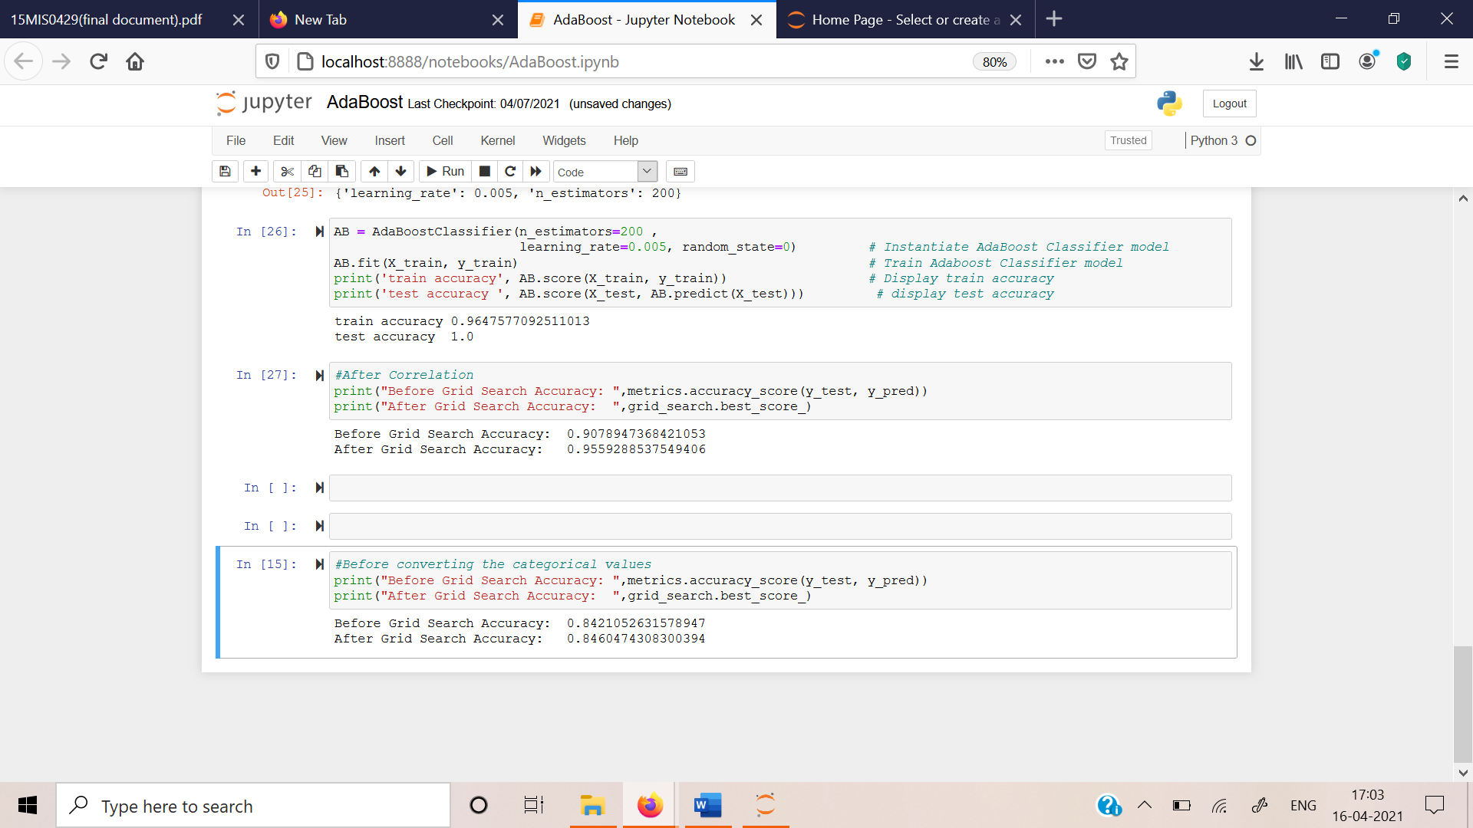

Fig.5.2.1 Adaboost algorithm Accuracy before pre-processing

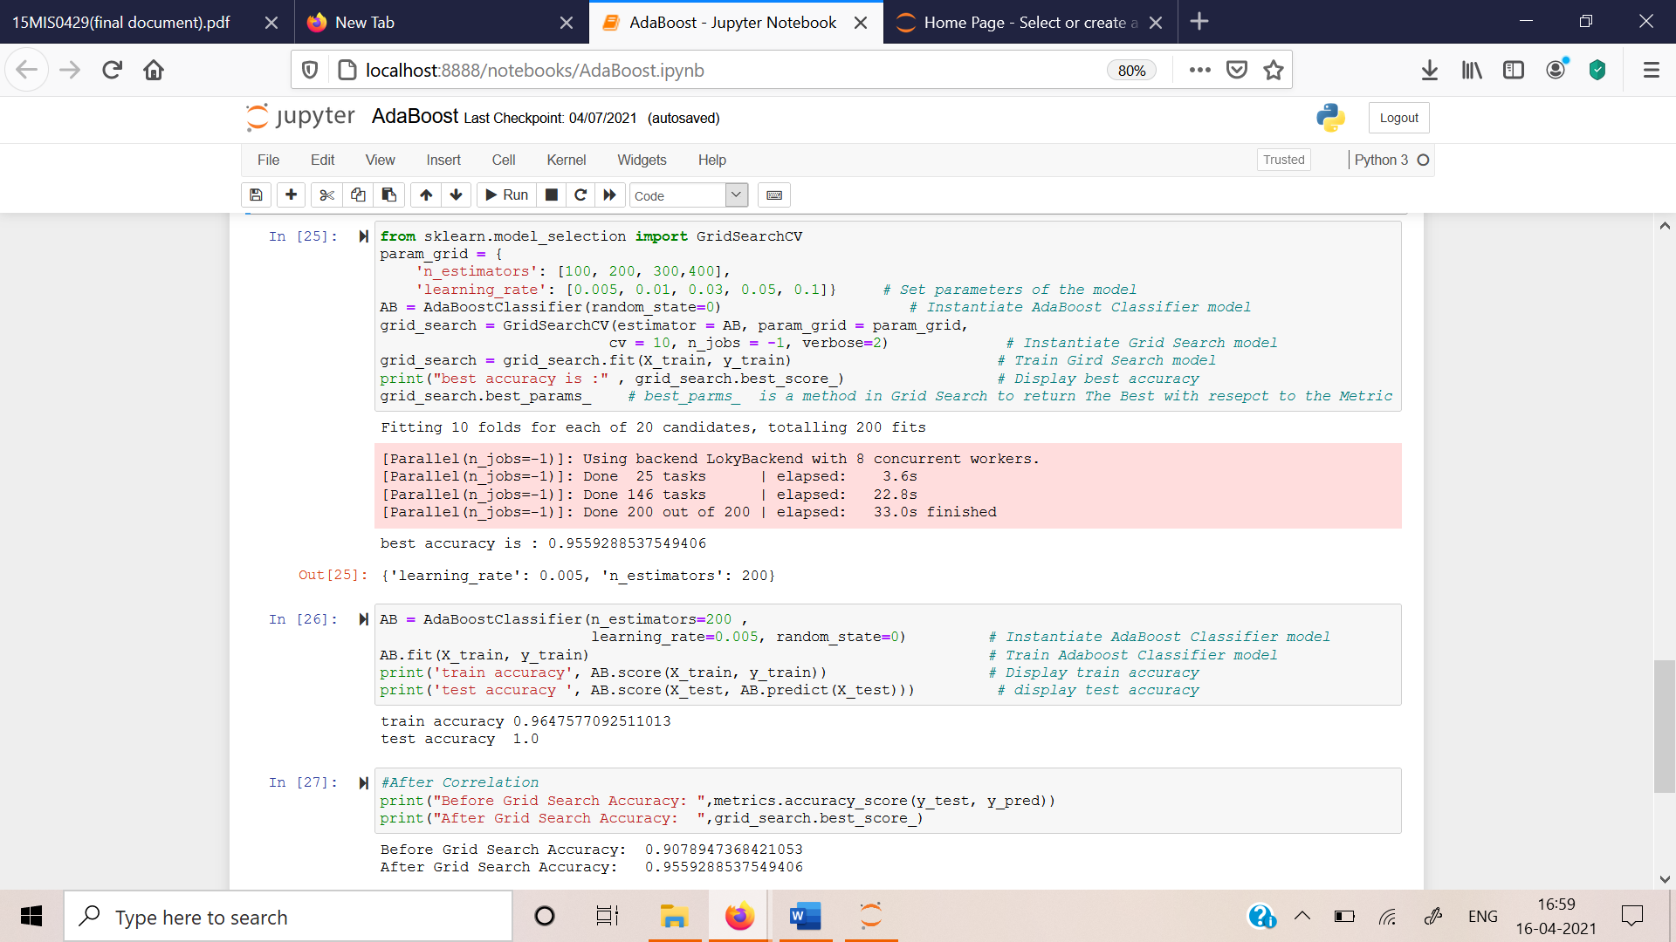

Fig.5.2.2 Adaboost algorithm Accuracy after pre-processing

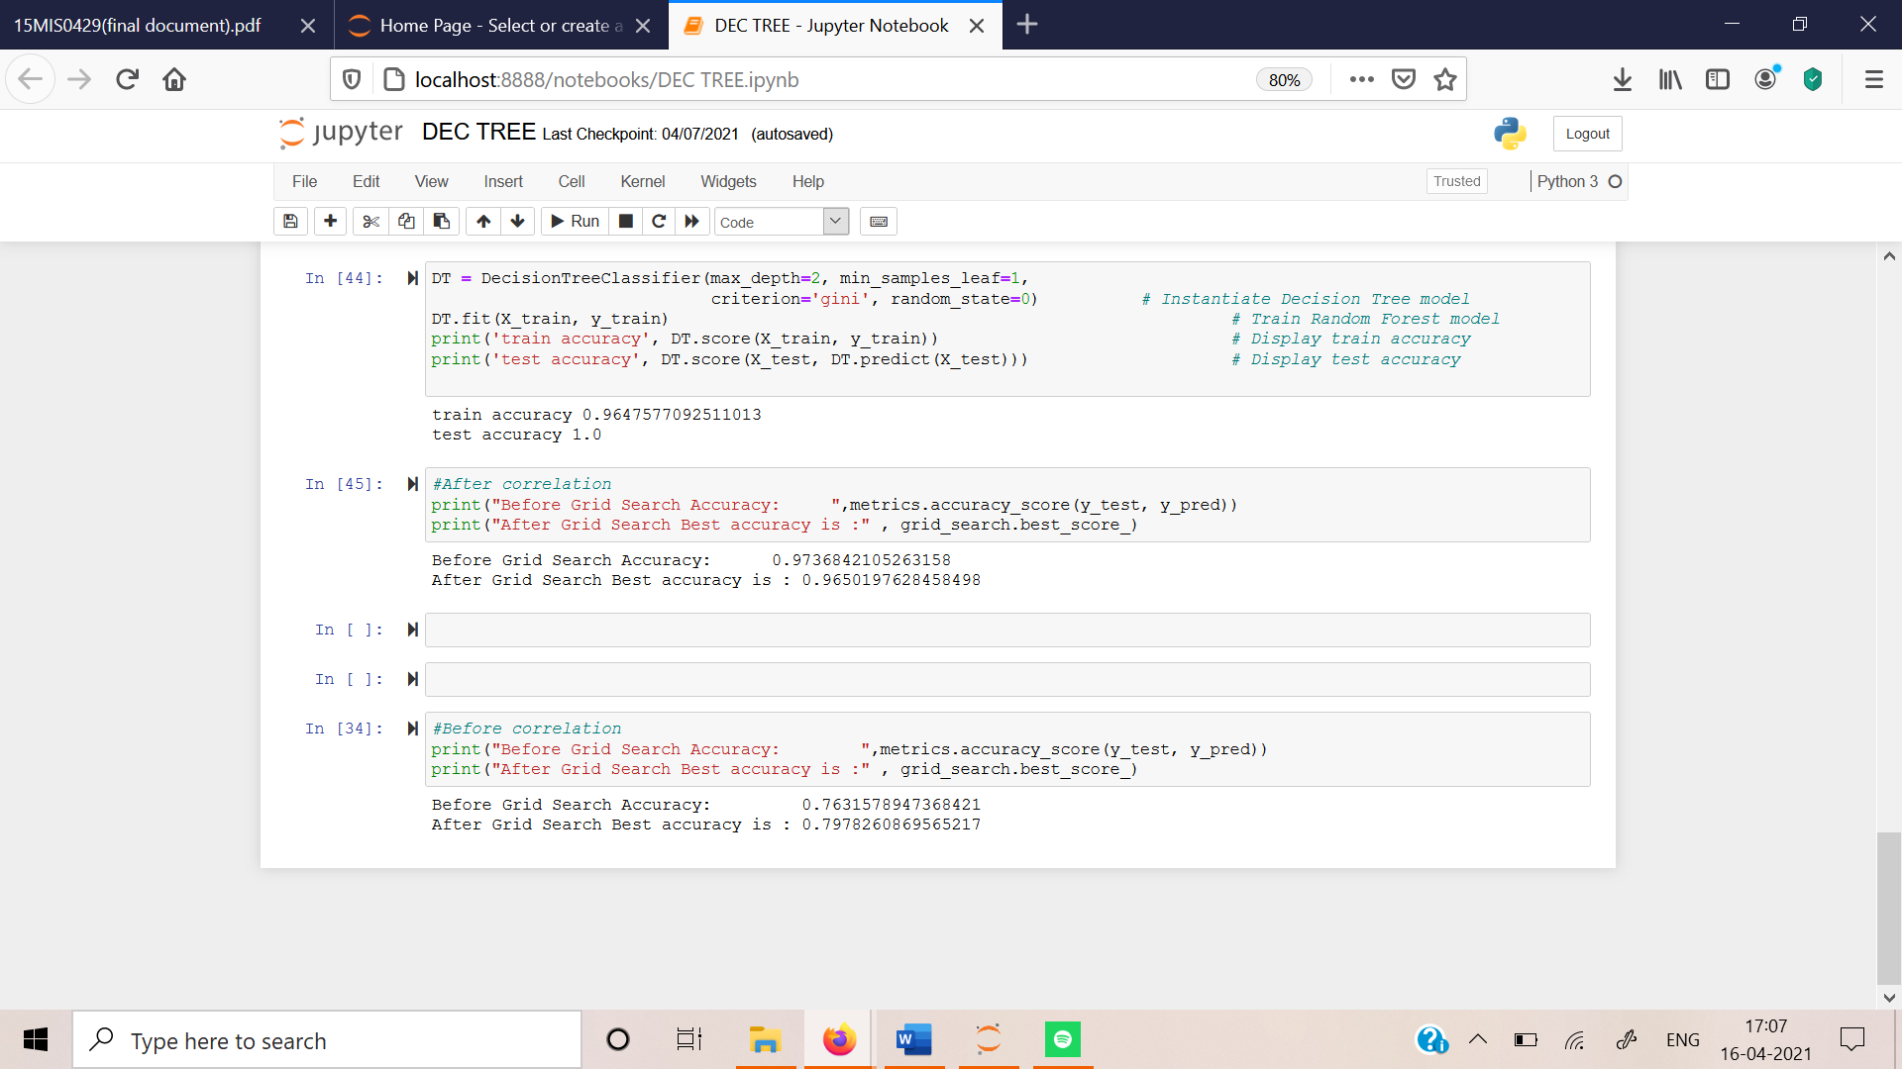

Fig.5.2.3 Decision Tree Accuracy before pre-processing

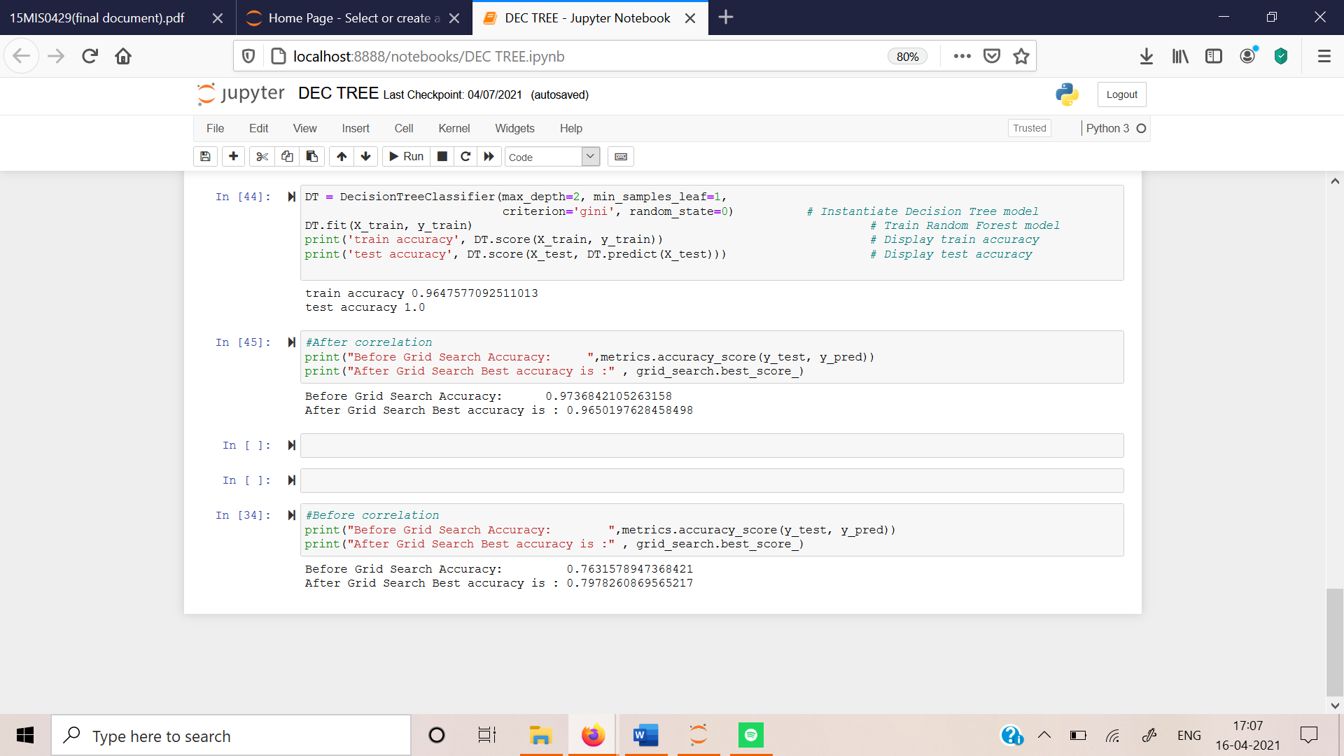

Fig.5.2.4 Decision Tree Accuracy after pre-processing

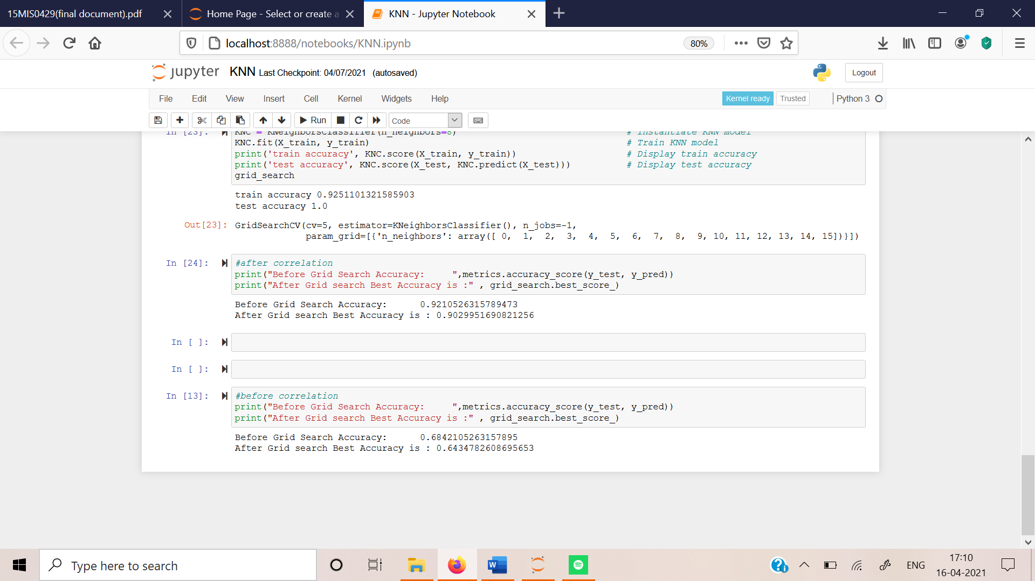

Fig.5.2.5 KNN Accuracy before pre-processing

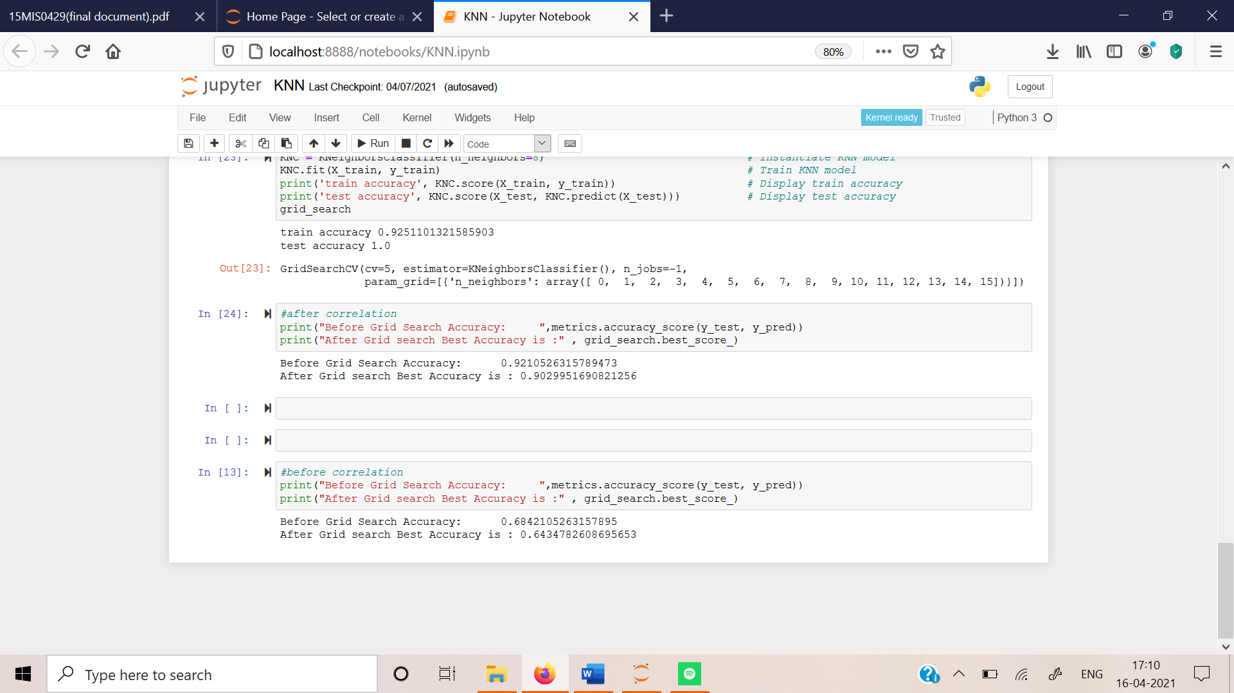

Fig.5.2.6 KNN Accuracy after pre-processing

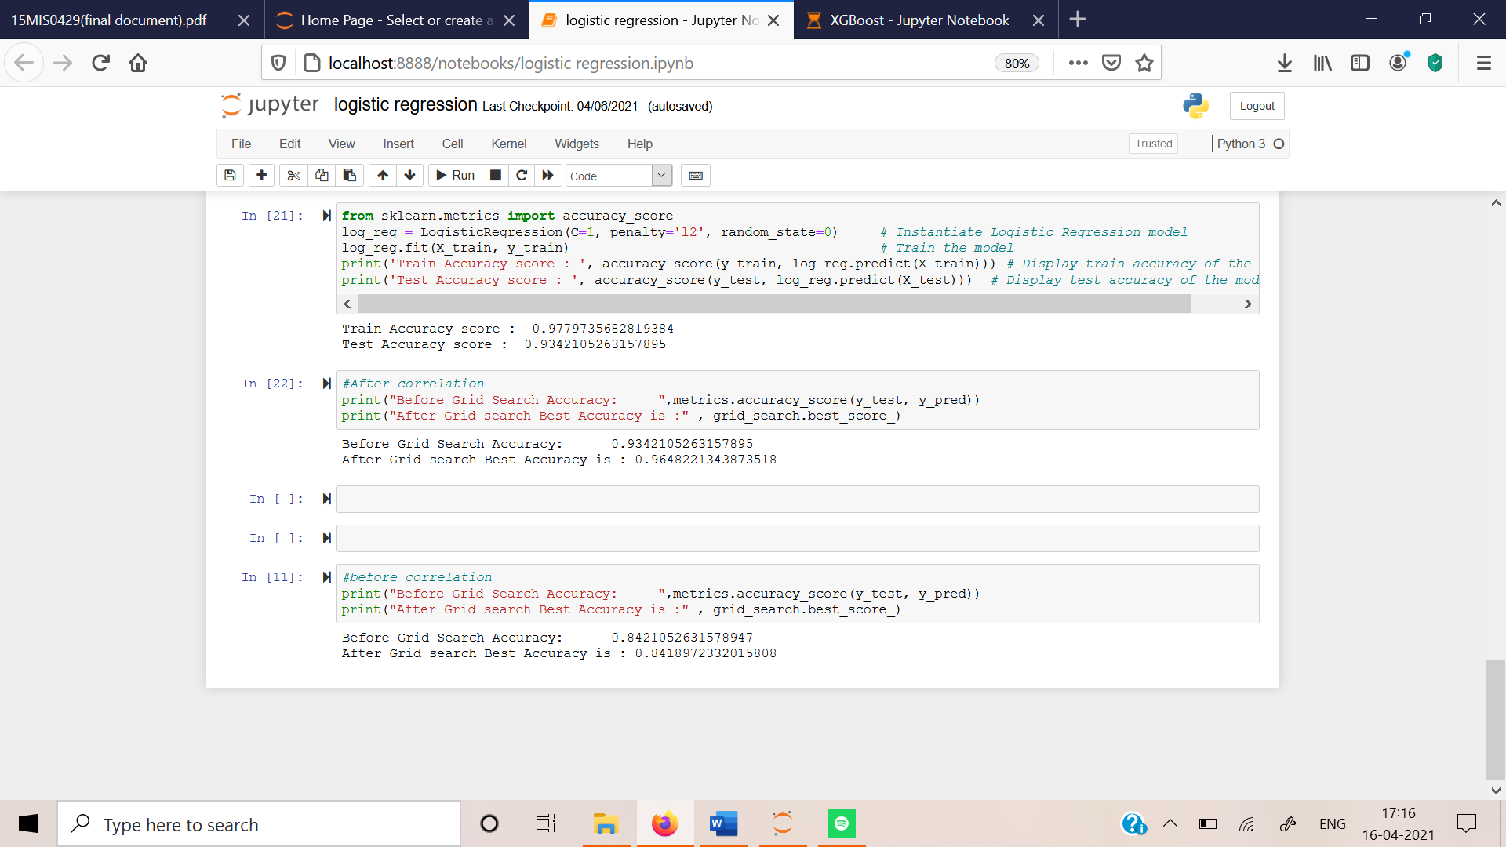

Fig.5.2.7 Logistic Regression Accuracy before pre-processing

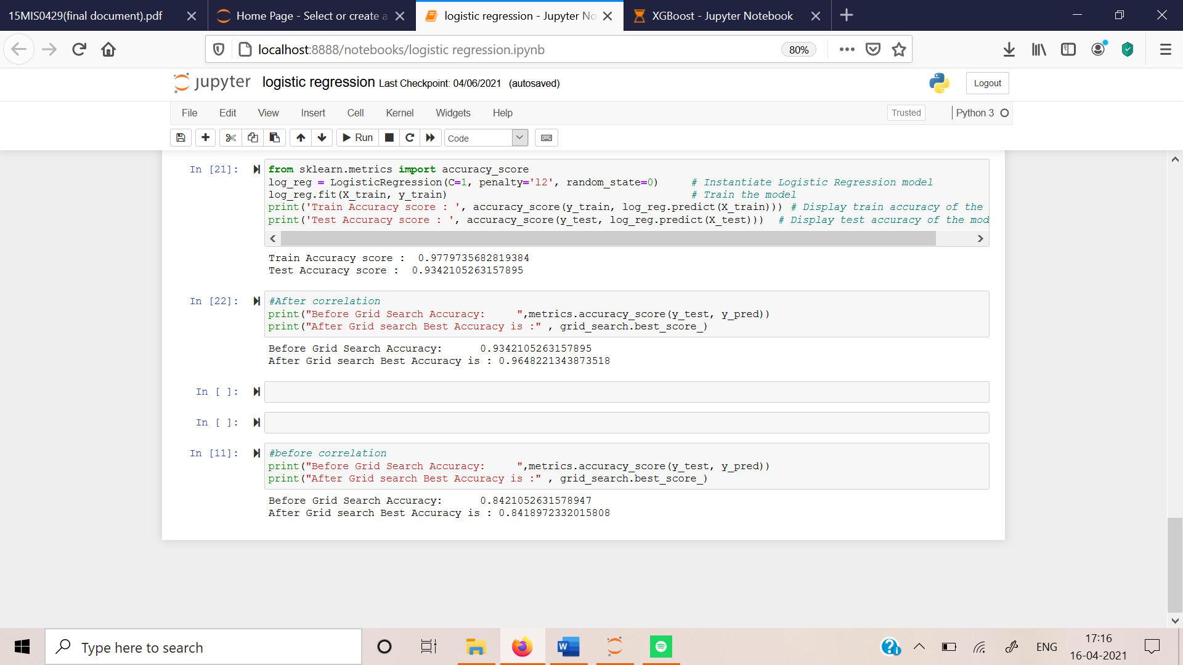

Fig.5.2.8 Logistic Regression Accuracy after pre-processing

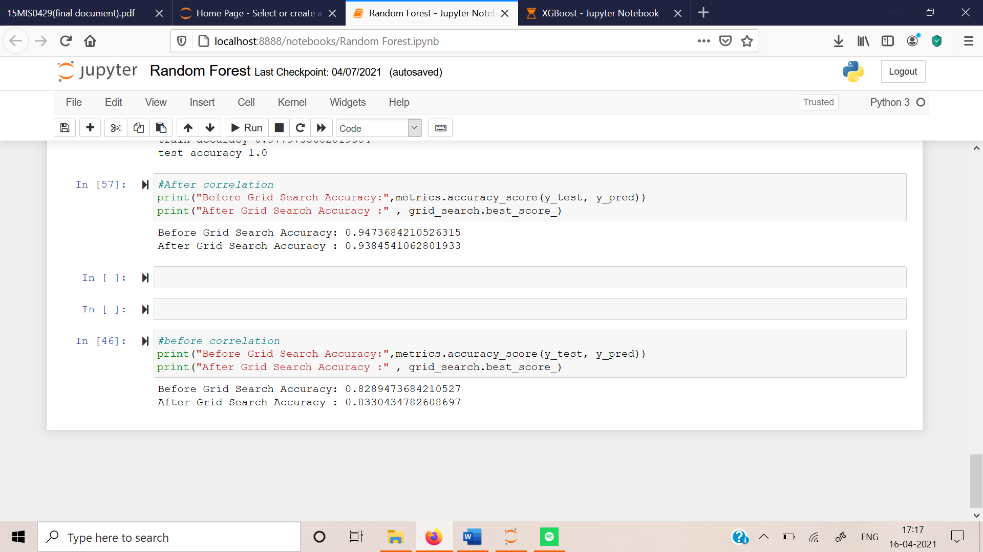

Fig.5.2.9 Random Forest algorithm accuracy before pre-processing

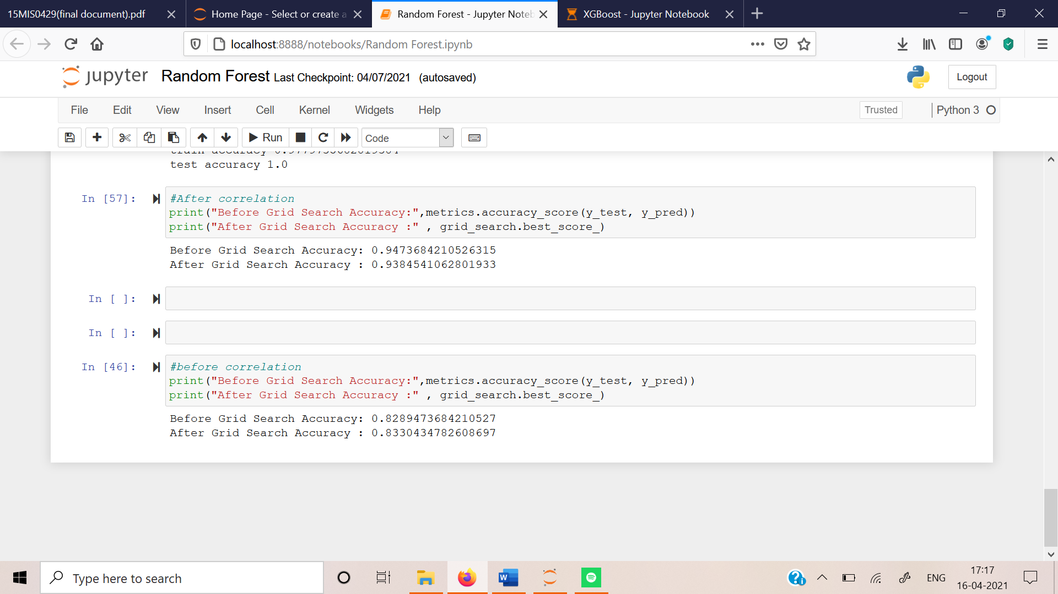

Fig.5.2.10 Random Forest algorithm accuracy after pre-processing

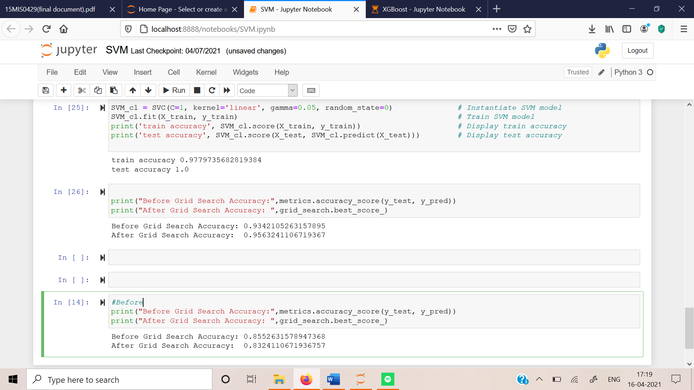

Fig.5.2.11 SVM algorithm accuracy before pre-processing

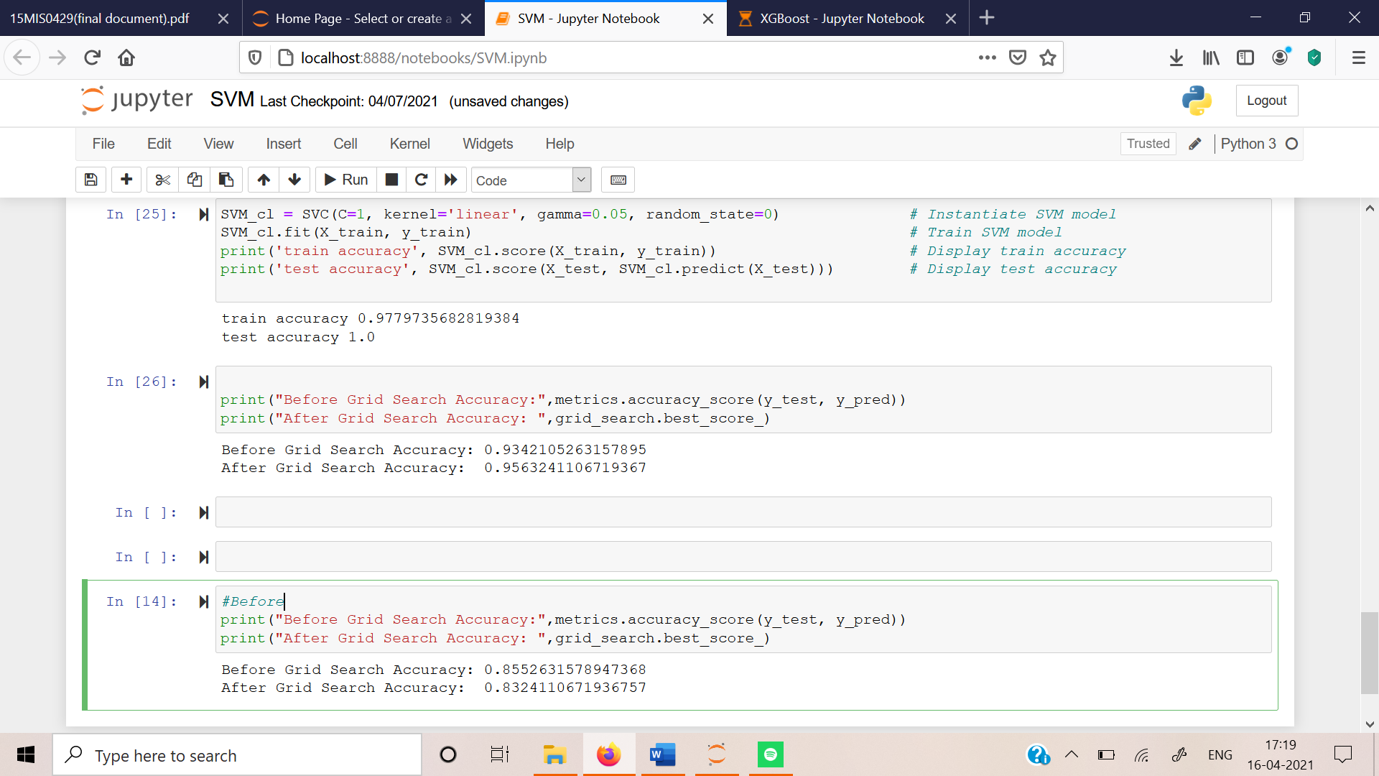

Fig.5.2.12 SVM algorithm accuracy after pre-processing

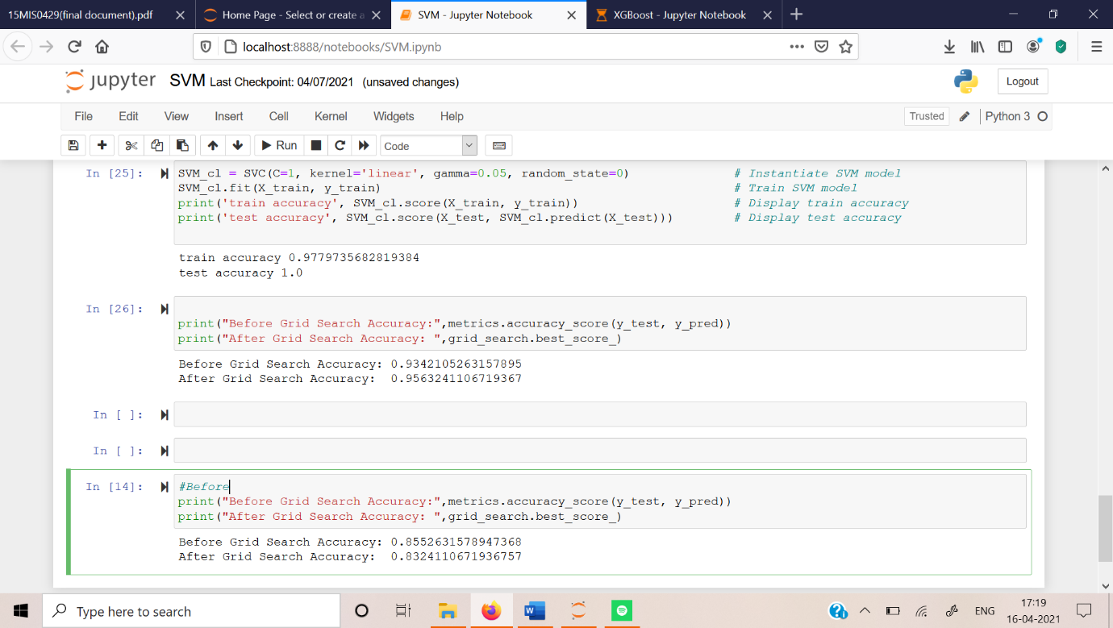

Fig.5.2.13 XGBoost algorithm accuracy before pre-processing

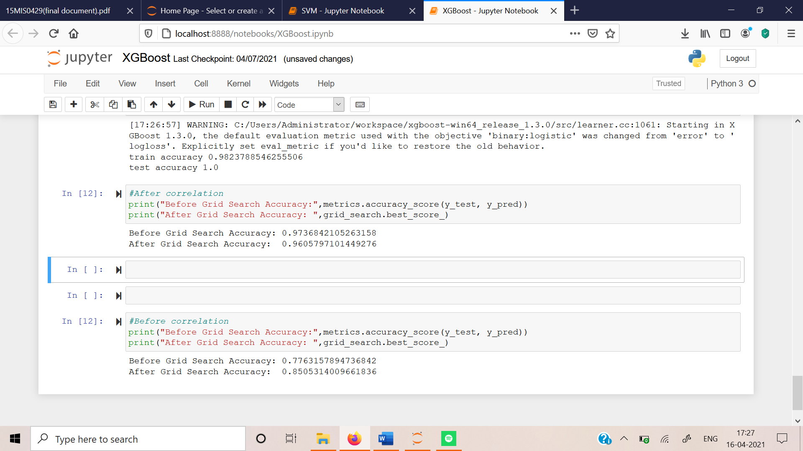

Fig.5.2.14 XGBoost algorithm accuracy after pre-processing

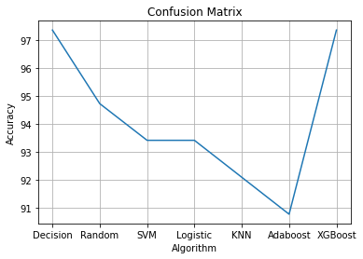

Fig.5.2.15 Graph representing all algorithms accuracy for Confusion Matrix

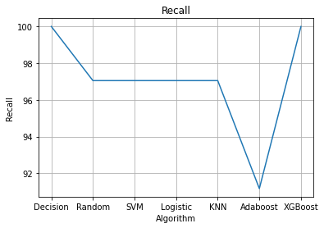

Fig.5.2.16 Graph representing all algorithms accuracy for Recall of Confusion Matrix

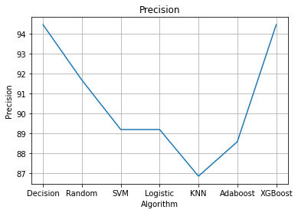Fig.5.2.17 Graph representing all algorithms accuracy for Precision of Confusion Matrix

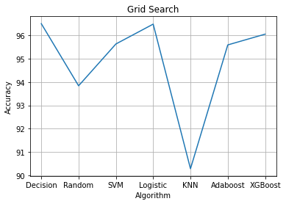

Fig.5.2.18 Graph representing all algorithms accuracy for Grid Search



Fig.5.2.19 Main page



Fig.5.2.20 Prevent page - 1

Fig.5.2.21 Prevent page – 2

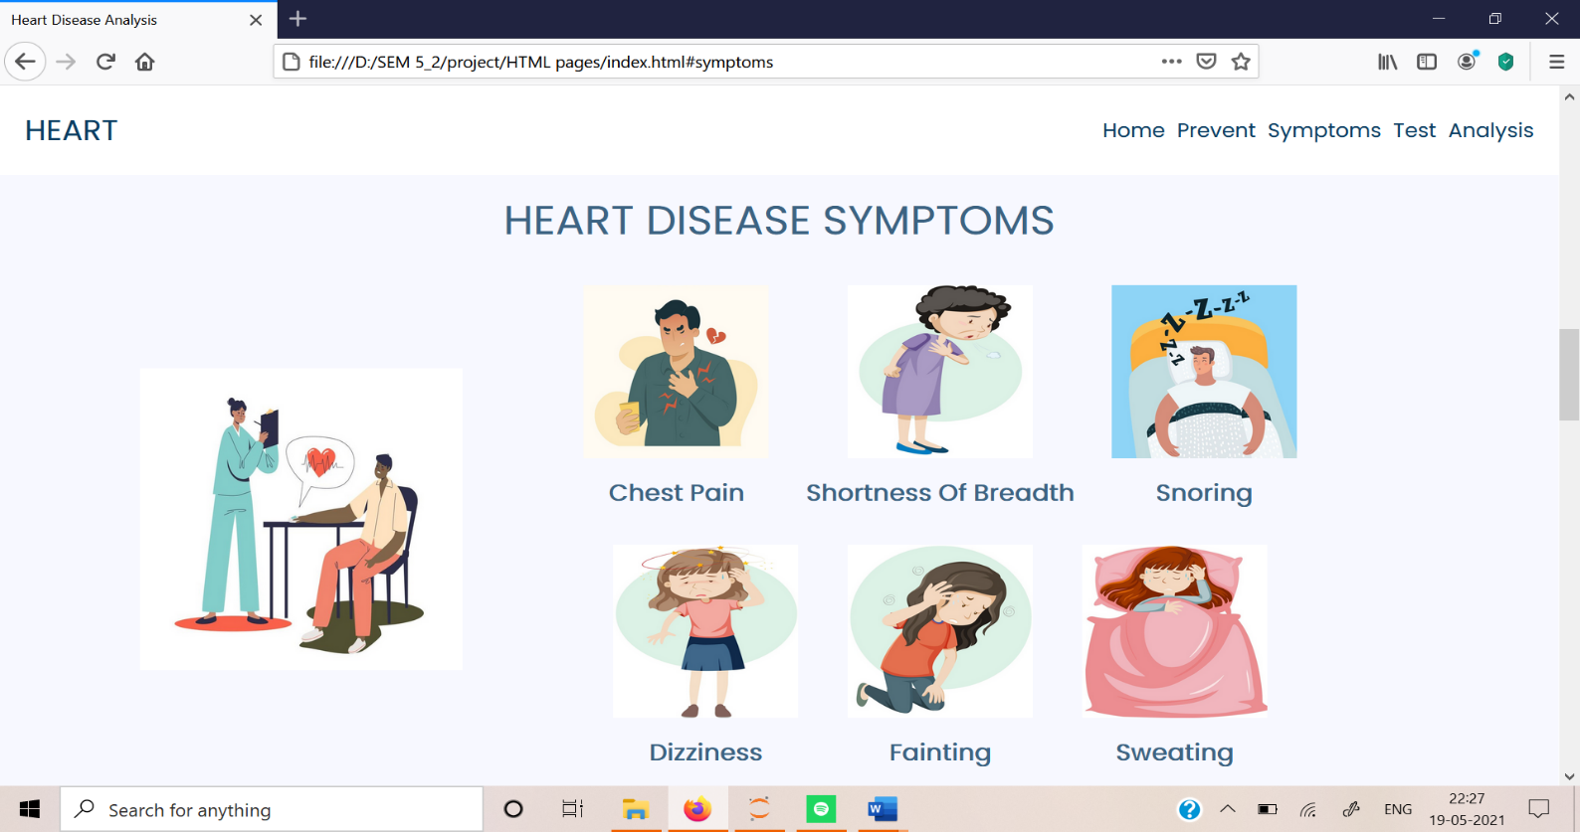

Fig.5.2.22 Symptom’s page

Fig.5.2.23 Test page -1



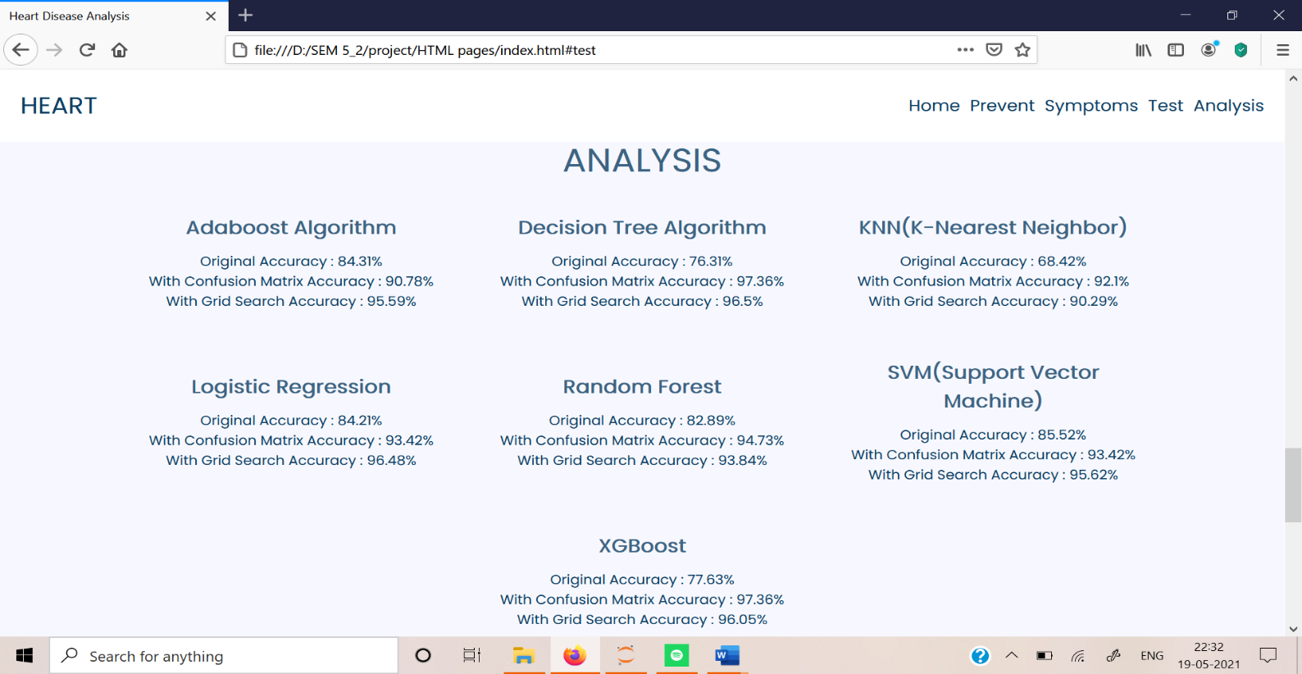Fig.5.2.24 Test page - 2

Fig.5.2.25 Analysis page – 1

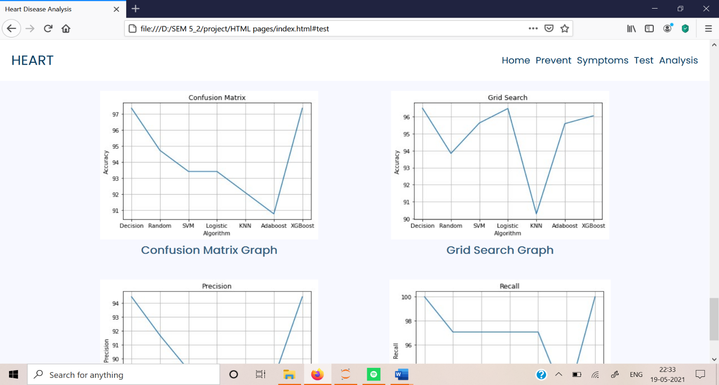

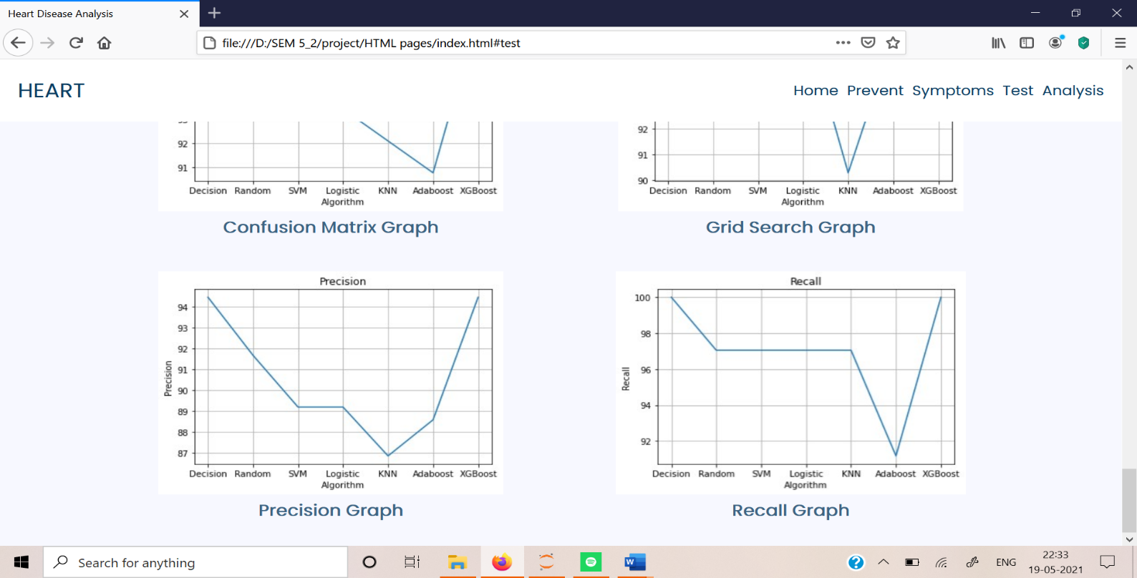Fig.5.2.26 Analysis page - 2

Fig.5.2.27 Analysis page – 3

**Chapter 6**

**Conclusion**

6.1 CONCLUSION

Modern science has been developing from time to time. The technology made the disease diagnosis much easy and faster. Based on the data provided by the user we can predict whether the condition of the patient is critical or it is manageable. Heart disease has been seen in various people irrespective of age, and if not been diagnosed properly the patient condition will worsen and eventually lead to dead. In order to help the doctors to predict whether they are having the heart disease or not based on the patient’s information the machine learning concepts has been helping a lot. The highest accuracy I have achieved in this project is 97.368 for both XGBoost and Decision Tree using confusion matrix.

6.2 FUTURE SCOPE

The accuracy achieved for the heart disease prediction is 97.36% but, in the future, I will like to try to achieve 99% accuracy and, I will try to use a digital watch and predict based on that data.

**Chapter 7**

**References**

7.1 REFERENCES

1. Fitriyani, N. L., Syafrudin, M., Alfian, G., & Rhee, J. (2020). HDPM: An Effective Heart Disease Prediction Model for a Clinical Decision Support System. *IEEE Access*, *8*, 133034-133050.
2. Khan, M. A. (2020). An IoT framework for heart disease prediction based on MDCNN classifier. *IEEE Access*, *8*, 34717-34727.
3. Ayon, S. I., Islam, M. M., & Hossain, M. R. (2020). Coronary artery heart disease prediction: a comparative study of computational intelligence techniques. *IETE Journal of Research*, 1-20.
4. Gárate-Escamila, A. K., El Hassani, A. H., & Andrès, E. (2020). Classification models for heart disease prediction using feature selection and PCA. *Informatics in Medicine Unlocked*, *19*, 100330.
5. Dutta, A., Batabyal, T., Basu, M., & Acton, S. T. (2020). An efficient convolutional neural network for coronary heart disease prediction. *Expert Systems with Applications*, *159*, 113408.
6. Mienye, I. D., Sun, Y., & Wang, Z. (2020). Improved sparse autoencoder based artificial neural network approach for prediction of heart disease. *Informatics in Medicine Unlocked*, *18*, 100307.
7. Ishak, A., Ginting, A., Siregar, K., & Junika, C. (2020, December). Clasiffication of Heart Disease using Decision Tree Algorithm. In *IOP Conference Series: Materials Science and Engineering* (Vol. 1003, No. 1, p. 012119). IOP Publishing.
8. Singh, A., & Kumar, R. (2020, February). Heart disease prediction using machine learning algorithms. In *2020 international conference on electrical and electronics engineering (ICE3)* (pp. 452-457). IEEE.
9. Sandhiya, S., & Palani, U. (2020). An effective disease prediction system using incremental feature selection and temporal convolutional neural network. *Journal of Ambient Intelligence and Humanized Computing*, *11*(11), 5547-5560.
10. Haq, A. U., Li, J. P., Memon, M. H., Nazir, S., & Sun, R. (2018). A hybrid intelligent system framework for the prediction of heart disease using machine learning algorithms. *Mobile Information Systems*, *2018*.

7.2 BASE PAPER

* **Reference:**

Khan M. A. (2020). An IoT framework for heart disease prediction based on MDCNN classifier. *IEEE Access*, *8*, 34717-34727.

* **Author Name:** Mohammad Ayoub khan
* **Link:** https://ieeexplore.ieee.org/abstract/document/9000918